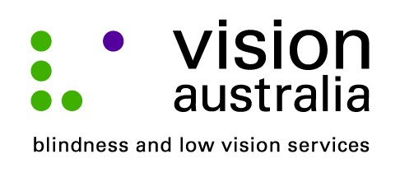
media release
24 June 2014
Big Plans for Young Ones
Last Saturday, four Illawarra families with children who are blind or have low vision, completed a one day course designed to assist parents who are raising children with a vision impairment.
For parents like Shelley Fretwell, mother to ten year old Shane, the Big Plans program, offered by Vision Australia has made an incredible difference.
“It was really good to get encouragement and reassurance that the things we are already doing are on track. I feel more confident that I can push him a little further to increase his independence,” said Ms Fretwell.
In addition to the Big Plans program for parents the children participated in a session called Operation Teamwork.
According to Bronwyn Wilson an Occupational Therapist from Vision Australia’s Fairy Meadow site, Operation Teamwork, assists children to develop skills in a way that is specific to their vision impairment.
“The courses were designed by Vision Australia to help prepare children who are blind or have low vision to be ready to find a job when they finish school,” says Ms Wilson.
“The unemployment rate for people who are vision impaired is around four times the national average so teaching them skills at such a young age is really powerful,” she added.
Melissa Perrine, a downhill alpine skier, who represented Australia at the recent Winter Olympics, was also on hand to reassure parents that living with a vision impairment needn’t stop you from following your dreams.
“It was good to hear from Melissa. She inspired me to continue to let Shane follow his dreams, and, no matter how impossible they may seem, you can usually find a way to make them happen. It is all about being brave and having a go,” said Ms Fretwell.
The program was supported by the generosity of The Mudford Fund for Young People who are Vision Impaired, set up by the generosity of Vision Australia donor and volunteer, Pam Mudford who left $750,000 in trust to support children who are blind or have low vision in regional areas. For more information about how you can contribute contact Fiona Jessiman on (02) 9334 3307.

