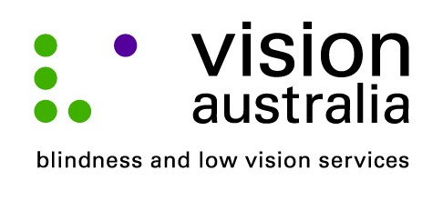
media release
20 June 2014
Stepping stones to a positive future
This Thursday, nine Brisbane families with children who are blind or have low vision, will celebrate the completion of a nine week face-to-face program designed to address the extra challenges of raising a child with a disability.
For parents like Malcolm Stanfield, dad to six year old Isabella, the Stepping Stones Triple P (SSTP) program, offered by Vision Australia has made an incredible difference.
“The course helped to reassure me that I was on the right track. I learnt different strategies to cope with different situations. One of the most effective things was to stop what I was doing and listen more closely when Isabella talks to me. As a busy single dad that is challenging, but very worthwhile. It has definitely improved our relationship,” said Mr Stanfield.
Courtney McKee, a Paediatric Counsellor at Vision Australia and accredited SSTP provider believes the course is extremely effective in promoting positive behaviour.
“When parents commit to attending the full nine week program the results are incredible. Parents feel empowered to manage misbehaviour and can teach new positive behaviour,” says Ms McKee.
What: Vision Australia’s SSTP celebration
When: Thursday 26 June, 3:30 to 6:30pm
Where: Vision Australia, 373 Old Cleveland Road, Coorparoo, QLD
Photo opportunity: During the celebration, visiting author Donna Dyson will present the children with a hand made tactile book kit, kindly donated by Queensland Museum.
Developed by clinical psychologist Professor Matt Sanders and his colleagues at Australia's University of Queensland, the Triple P – Positive Parenting Program gives parents simple and practical strategies to help them confidently manage their children’s behaviour, prevent problems developing and build strong, healthy relationships. Triple P is currently used in 25 countries and has been shown to work across cultures, socio-economic groups and in all kinds of family structures.

