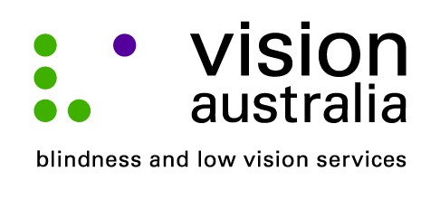
28 August 2014

Optometrists hail Vision Australia’s NSW spectacles program a success
Over 4,500 applications for spectacles have been received following Vision Australia’s relaunch of the NSW Spectacles Program in July 2014.
Vision Australia’s new delivery approach streamlines the application process, provides greater information and resources to optometrists/dispensers and improves delivery times to recipients of glasses.
Kyriacos Mavrolefteros a Maroubra based optometrist who also delivers services in remote NSW, identifies two big advantages to the new approach.
“After trialling the new system, the biggest benefit is being able get an immediate response on a patient’s eligibility. The online form only takes around three to four minutes to complete and the response comes through straight away,” says Mr Mavrolefteros.
“I also like being able to process orders directly with my suppliers,” says Mr Mavrolefteros. “Instead of waiting up to four weeks, patients receive their spectacles within a week. It is much more efficient.”
Mr Mavrolefteros, who has been involved with the NSW Spectacles Program for around 20 years, processes around 400 applications for spectacles annually, 200 of which are for patients living in regional and remote areas.
“Susie, from Vision Australia came out to my clinic to train two of my staff on how to use the new online system. She also assisted us to process a backlog of applications,” he said. “Vision Australia has been very helpful throughout the transition,” he added.
Michael Christensen from The Optical shop in Campbelltown says it gives him a new avenue for sale stock.
“For the first time, there is another option to turn over last season’s premium stock. Instead of having a sale, I can use older frames for the program,” he said.
Like Mr Mavrolefteros, Mr Christensen also felt that he was able to offer a faster service to his patients.
“Because I fit the lenses to the fames on site, patients receive their glasses in a matter of days not months. The remuneration is far better and the online form is quick and easy to use,” he said.
“I understand that the administration of the scheme is an evolutionary process, and I have been impressed with Vision Australia’s ability to resolve issues quickly,” said Mr Christensen.
The NSW Spectacles Program provides Government funded glasses and vision aids to eligible people including the elderly, children, people experiencing homelessness, those living in rural and remote areas, people with disability and Aboriginal and multicultural communities.
For more information, visit the website at www.visionaustralia.org/spectacles.

Optometrists available for interview:
- Kyriacos Mavrolefteros, phone, 02 9314 0318

- Michael Christensen, phone, 02 4626 1335

- Janis Stein, phone, 02 9649 3675
“It is definitely much quicker to process online than using the complicated written forms. The jobs come through much more quickly and it’s good to be able to use your own suppliers to negotiate the best deal,” said Ms Stein.

- Helen Radobanovic, who works with Mr Fuad Safraz, an optometrist from Custom Eyes in Liverpool, phone: 9601 5444.
“Before, there was a lot of paperwork to complete, now it is all on the computer it is much more straightforward,” said Ms Radobanovic. “Everything is done so quickly,” she added. “It is a much faster service and our patients are very happy to receive their spectacles sooner, ” says Ms Radobanovic.

