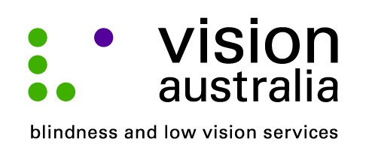
23 September 2014

Technology opens up a new world to Patricia
When Patricia Ross lost her sight to Macular Degeneration, it knocked her flat. She felt she had lost her independence. But now, thanks to expert training from Vision Australia, this 76 year old Great Grandmother from Colyton is right up to speed with the very latest accessible technology.
“I’m not totally blind, I have some vision in my right eye, but I can’t read, watch television or use a computer unless it is magnified,” says Patricia. “When I had to stop driving, I was devastated. I couldn’t get myself to the gym or my clubs and I had to rely on my husband. It was a very hard time for me.”
Patricia, who was once president and secretary of the local VIEW club, also thought her vision loss meant she could not continue to use a computer. “I used to book holidays and use BPAY to pay bills, but I couldn’t use the internet anymore so I just thought why bother,” she said.
Now, after completing training with Adaptive Technology Consultants at Vision Australia’s Sydney facility, Patricia is able to independently use an iPhone and an iPad to make phone calls, check emails and speak to her sister in England via messenger.
“At first I thought I was holding the class back, but they were so supportive. Vision Australia even arranged some 1:1 training for me with a volunteer to bring me up to speed,” said Patricia.
Vision Australia’s Texpo, held this October, showcases the very latest technology and services for people who are blind or have low vision. Real-life scenarios based on home, work, education and employment environments will enable visitors to experience how Vision Australia provides expert advice, training, equipment and support for every part of life.
“Technology is developing so quickly and it is important to learn about what is now on offer,” said Patricia.
In 2014, Texpo will take place at:
Vision Australia Sydney
4 Mitchell St, Enfield
- Friday 17 October, 10am – 4pm
- Saturday 18 October, 10am – 3pm
Vision Australia provides a range of services and supports that assist people like Patricia to live the lives they choose.
Whether it is help accessing education, developing skills to stay independent at home, or providing social and emotional support and connecting with others, the options are many.
Find out more about Vision Australia’s services today. Call us on 1300 84 74 66or visit our website www.visionaustralia.org.

