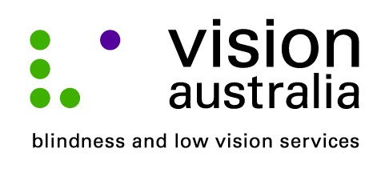
23 September 2014

New technology helps Laurinda live life to the full
Forty-four year old, Laurinda Martin, from Mount Warrigal is legally blind, but thanks to the latest technology, and expert training from Vision Australia, she doesn’t let her vision impairment slow her down.
Laurinda, a receptionist for the Flagstaff group at Unanderra, has Retinitis Pigmentosa and Rod Cone Dystrophy and can only distinguish between light and dark.
“Technology has made a huge difference in my life,” said Laurinda. “I already use an iPhone and an iPod and I recently purchased a Mac so I can use the computer at home for writing, making notes and updating my telephone directory. I also use technology to keep in touch with people via Facebook, email and messenger.”
For the first time in the Illawarra, Laurinda can seek expert training from a local Adaptive Technology Trainer, Irina Bruckner, who is based at Vision Australia’s Fairy Meadow centre.
“It is very exciting to be able to access technology training locally. I use VoiceOver and Irina is teaching me how to use the word processing program ‘Pages’ as well as basic commands to navigate the computer,” said Laurinda.
Laurinda also takes day off work to experience the latest technology and services for people who are blind or have low vision at Vision Australia’s annual Texpo event.
“I first visited in 2011 and I find it really helpful. This year I am hoping to purchase a product called The RealSam. It’s a device about the same size as an iPhone. You talk in to it, a bit like Siri, and it downloads newspapers and magazines via wifi,” said Laurinda.
Texpo is a free event, which is open to the general public, people who are blind or have low vision, their friends and family, and industry professionals.
In 2014, Texpo will take place at:
Vision Australia Sydney
4 Mitchell St, Enfield
- Friday 17 October, 10am – 4pm
- Saturday 18 October, 10am – 3pm
Vision Australia provides a range of services and supports that assist people like Laurinda to live the lives they choose.
Whether it is help accessing education, developing skills to stay independent at home, or providing social and emotional support and connecting with others, the options are many.
Find out more about Vision Australia’s services today. Call us on 1300 84 74 66, drop in to the local office at 2/135-143 Princes Hwy, Fairy Meadow, or visit our website www.visionaustralia.org .

