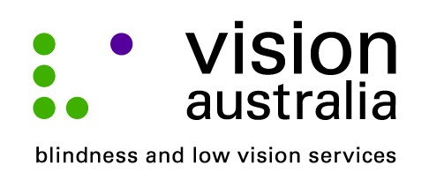
09 September 2014

Technology changes lives
When she lost her sight five years ago, Argentinian born Patricia Cardozo, 61, from Southport thought she would never be able to use email to contact her friends and family.
But, thanks to an iPad and some training from Vision Australia she is discovering that anything is possible.
Patricia lost her vision after she had an allergic reaction to steroid eye drops that she was using to treat Macular Dystrophy, an eye condition that causes gradual deterioration of central vision.
“It was a slow loss at first. I’d get flashes then maybe have a problem for an hour or two, but one day I had nothing. I woke up and I couldn’t see anything but black. I called my daughter to help me. It was very frightening,” said Patricia.
“Suddenly all my world was crushed. It was devastating. I couldn’t do all the things I enjoyed, like reading books, crochet and learning new things,” she added.
Patricia contacted Vision Australia and now she is attending one-on-one training at Vision Australia’s centre in Robina, to help her use an iPad to stay connected with her friends and family still living in Argentina.
“I have been training Patricia with the iPad for around two months,” says Denise Merritt, Adaptive Technology Trainer at Vision Australia. “It is a great tool. The interface is much simpler to use than a PC and their talking software makes it very accessible for people who are blind or have low vision to use.”
“It has been an extra challenge to manage the language difference as Patricia natively speaks Latin American Spanish and has a very strong Spanish accent. She also speaks fluent Italian. We use Voiceover technology to navigate the device and Siri, in English, Italian and Spanish to produce and read emails for Patricia.”
Vision Australia provides a range of services and supports that assist people like Patricia to live the lives they choose.
Whether it is help accessing education, developing skills to stay independent at home, or providing social and emotional support and connecting with others, the options are many.
Find out more about Vision Australia’s services today. Call us on 1300 84 74 66, drop in to our local office on level one in the Easy T Centre, 510 – 514 Christine Avenue, Robina, or visit our website on www.visionaustralia.org.

