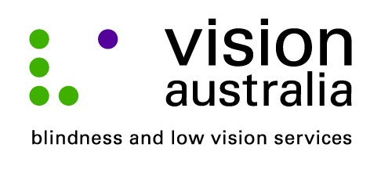
9 September 2014

Technology changes lives
Four years ago, sixty two year old Bruce Blackshaw from Croydon Park, was devastated when he lost his eyesight overnight. The then TAFE head teacher had a form of optic neuropathy known as Non-Arteritic Ischemic Optic Neuropathy (NAION).
“It is like a mini stroke or bleed at the back of my optic nerve. It means I can only see outlines. I can’t read print, unless it is extra large and I can’t see people’s faces,” Bruce explained.
It was an emotional time for Bruce. He attended a low vision clinic at Vision Australia and joined an eight week Quality Living Group program, which provides peer support to people dealing with vision loss.
“I was in the Quality Living Group for four weeks before I could talk about my experience,” says Bruce. “It was a really tough time.”
It was while he was at the Quality Living Group that Bruce found out about Texpo, Australia’s largest technology and services exhibition for people who are blind or have low vision.
“The event blew me away. I discovered magnification, video readers, and voice over software. I attended a seminar about Apple products led by David Woodbridge and I was amazed at what he could do,” said Bruce.
Bruce is about to complete a Masters in Education by Research and afterwards he intends to apply for a doctorate.
“I use technology every day. I use an app on my iPhone that tells me when my bus is due and how far away it is. GPS helps me to find my way in unfamiliar places or find out where I am, and another app called Dragon Dictation is really useful for typing up my research interviews. Without Texpo I wouldn’t have known the possibilities out there. It has opened up my world.”
Texpo is a free event, which is open to the general public, people who are blind or have low vision, their friends and family, and industry professionals.
In 2014, Texpo will take place at:
Vision Australia Sydney
4 Mitchell St, Enfield
on Friday 17 October, 10am – 4pm
and Saturday 18 October, 10am – 3pm

For more information call Vision Australia on 1300 84 74 66 visit www.visionaustralia/texpo or email info@visionaustralia.org

