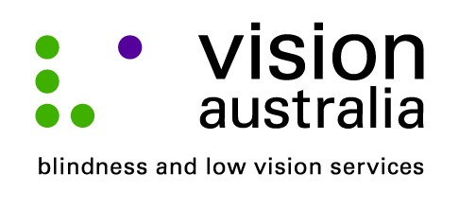
media release
Friday, 9 May 2014
Cinema improves access for patrons who are blind
Going to the movies is not necessarily something that you would think people who are blind or have low vision would enjoy.
However, thanks to audio description, a service that provides visual information in the gaps between the dialogue, people like Rhonda McGaw from Narellan Vale are able to more fully enjoy and experience the latest Hollywood blockbusters.
On Tuesday 13 May, at 11am, Event Cinema’s in Campbelltown is hosting a special movie session of “THE GRAND BUDAPEST HOTEL” to enable local people who are blind or have low vision to experience an audio described movie. The initiative came about after Ronda, who has Glaucoma and cataracts, visited the cinema chain on a night out.
“My husband and I decided to go to the movies and we chose a film that had been advertised as audio described. Unfortunately when we got there, the staff didn’t know how to help me,” said Rhonda. “The cinema manager approached me immediately afterwards to apologise,” she added.
Rhonda, who runs Macarthur vision impaired support group was pleased when he agreed to host a group of vision impaired people at a special screening.
“It is not just cinema staff who don’t know about audio description said Rhonda, many people who are blind or have low vision don’t know either. The screening is a great way to encourage more people to make use of the service and in turn hopefully cinema staff will be come more familiar with the terminology,” she said.
Michael Ward, Vision Australia’s National Audio Description Coordinator congratulates Event Cinema Campbelltown for partnering with Vision Australia to give people who are blind or have low vision the chance to experience audio described cinema for the first-time.
Michael explains, “Audio Description is an additional narration track that weaves between the dialogue giving succinct details of the visual elements. This means people unable to see the screen can follow the movie’s plot, scene changes, the characters and their non-verbal gestures. This essentially ‘fills in the gaps’ ensuring someone who is blind or has low vision can fully experience all the elements that can make a trip to the cinema an enjoyable one.”
Andrew Fenessy Assistant General Manager at Event Cinema in Campbelltown says, “Event Cinemas Campbelltown is proud to offer Audio Description for people with vision impairments. Customers can check session details or ask a team member for enabled screenings.”

More information about audio described cinema sessions can be found at www.eventcinemas.com.au
For more information about audio described events, such as cinema, DVD’s and live theatre contact Michael.Ward@visionaustralia.org 02 93343533.
Local people interested in joining the Macarthur vision impaired support group should contact Rhonda on 0419 412 087.
“Our group caters for people from age 20 to those in their 80’s. We meet on the 1st Tuesday of each month at the Macarthur Disability Services office in Campbelltown. I encourage anyone who is finding that they are struggling with their eyesight to contact us and get involved,” said Rhonda.

