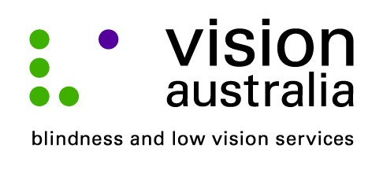
media release
Thursday, 04 September 2014
Cinema improves access for patrons who are blind
Going to the movies is not necessarily something that you would think people who are blind or have low vision would enjoy.
However, thanks to Audio Description (AD), a service that provides visual information in the gaps between the dialogue, people like Bob James from Kambah, are able to more fully enjoy and experience the latest Hollywood blockbusters.
Bob has an eye condition called Retinitis Pigmentosa, which causes tunnel vision. It is a degenerative condition and at 70, Bob is able to only able to make out light and dark as well as distinguish moving objects.
“Audio description makes a tremendous difference. I can keep up with the movie and it saves my wife having to whisper in my ear or read aloud the captions that set the scene,” said Bob.
On Wednesday 10 September, at 11am, Hoyts Cinema in Woden is hosted a special movie session of “The Hundred-Foot Journey” to enable local people who are blind or have low vision to experience an AD movie.
“Unfortunately, not many movie sessions are available as audio described, and when they are often staff don’t know the correct equipment to provide. It is great that Hoyts have are running this awareness day. We have 12 participants attending and hopefully access to these movies will increase,” said Bob. “I’d love to take my 11-year old granddaughter to see a film,” he added.
Michael Ward, Vision Australia’s National AD Coordinator congratulates Hoyts Cinema Woden for partnering with Vision Australia to give people who are blind or have low vision the chance to experience audio described cinema.
Michael explains, “Audio Description is an additional narration track that weaves between the dialogue giving succinct details of the visual elements. This means people unable to see the screen can follow the movie’s plot, scene changes, the characters and their non-verbal gestures. This essentially ‘fills in the gaps’ ensuring someone who is blind or has low vision can fully experience all the elements that can make a trip to the cinema an enjoyable one.”
For more information visit www.visionaustralia.org or call 1300 84 74 66.

