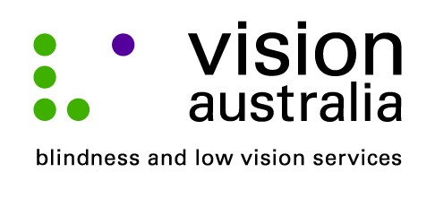
03 September 2014

Technology changes lives
Although she has very poor vision, thanks to an innovative Online talking book player developed by Vision Australia, Lesley McEwan, 60 from Willoughby reads more than sixteen books per month.
Lesley has poor sight due to cataracts. An operation to remove the cataract on her left eye left her vision foggy and she has a cataract on her right eye. She also has type-two diabetes and a heart condition that limits her mobility.
“I really enjoy receiving audio books from Vision Australia. With the new player, I just have to call and they are automatically downloaded. It is much faster than waiting to receive CD’s in the mail,” says Leslie.
The Online player was developed by Vision Australia to assist people with a print disability who do not have the capability or confidence to access online content. It involves bundling 3G (wireless broadband) internet technology into existing (DAISY) players that people are already familiar with.
The player connects directly to Vision Australia’s i-access© online library to access the wide range of books, newspapers, magazines and other topical information. The device is simple to use and the user does not need their own computer or internet connection.
“With the majority of our clients being older and with difficulties accessing content on the internet, we needed to develop a solution that would provide online access to a greater variety of information in a user friendly and effective way,” says Andrew Furlong, Technology Support Manager at the Vision Australia Library. “The 3G solution means that people can now get information immediately wherever they are on a device they are happy to use,” he added.
The Online audio book player will be demonstrated at Vision Australia’s Texpo exhibition in October.
Texpo showcases a range of Vision Australia services, including Seeing Eye Dogs, and the latest adaptive technology designed to assist people with vision impairments to live the lives they choose. It is a free event, which is open to the general public, people who are blind or have low vision, their friends and family, and industry professionals.
In 2014, Texpo will take place at:
Vision Australia Sydney
4 Mitchell St, Enfield
on Friday 17 October, 10am – 4pm
and Saturday 18 October, 10am – 3pm
For more information call Vision Australia on 1300 84 74 66 visit www.visionaustralia/texpo or email info@visionaustralia.org

