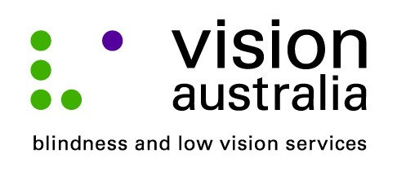
media release
Tuesday, 02 September 2014
Cinema improves access for patrons who are blind
Going to the movies is not necessarily something that you would think people who are blind or have low vision would enjoy.
However, thanks to Audio Description (AD), a service that provides visual information in the gaps between the dialogue, people like who are blind or have low vision are able to more fully enjoy and experience the latest Hollywood blockbusters.
On Monday 1 September, at 11am, Event Cinema in Burwood is hosted a special movie session of “The Hundred-Foot Journey” to enable local people who are blind or have low vision to experience an AD movie.
Michael Ward, Vision Australia’s National AD Coordinator congratulates Event Cinema Burwood for partnering with Vision Australia to give people who are blind or have low vision the chance to experience audio described cinema for the first-time.
Michael explains, “Audio Description is an additional narration track that weaves between the dialogue giving succinct details of the visual elements. This means people unable to see the screen can follow the movie’s plot, scene changes, the characters and their non-verbal gestures. This essentially ‘fills in the gaps’ ensuring someone who is blind or has low vision can fully experience all the elements that can make a trip to the cinema an enjoyable one.”
Event Cinemas Burwood has also agreed to include information about the AD session times on their telephone information line.
“We applaud Event Burwood for including AD session times on their telephone information line. This will certainly assist people who are blind or have low vision to easily find an Audio Described session time,” says Michael.
Vision Australia will demonstrate Audio Description at Texpo on 17 and 18 October. Texpo is a free event, open to the general public.
Vision Australia Sydney
4 Mitchell St, Enfield
Friday 17 October
10am – 4pm
Saturday 18 October
10am – 3pm

For more information visit www.visionaustralia.org/texpo or call 1300 84 74 66.

