Stroke

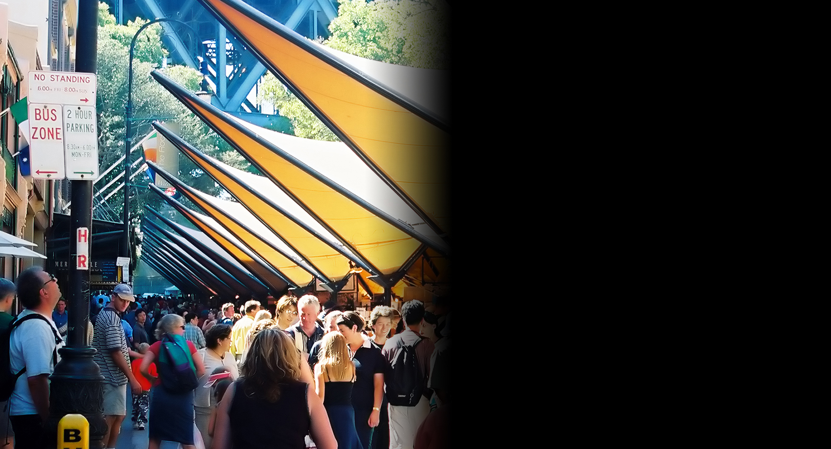
Stroke simulation
What is stroke?
Stroke happens when the blood flow to the brain is disrupted, cutting off oxygen supply and leading to brain cell death or damage.

In some cases, blood vessels spontaneously burst causing a haemorrhage (bleeding). A stroke is sometimes referred to as cerebral vascular accident (CVA).
Who is at risk?
Most people who have a stroke are aged over 65 but anyone can be affected, even children or unborn babies.

What are the common effects of stroke?
Depending on the part of the brain affected, stroke can cause permanent or temporary injury to:
- Movement
- Speech
- Thinking
- Communication
- Vision

How does stroke affect vision?
The cause of the stroke and area of the brain affected will determine the type of vision impairment.

Stroke can affect:
• Visual field – resulting in loss of side or peripheral vision
• Visual perception – resulting in impaired spatial awareness, neglect or object recognition
• Visual acuity – resulting in blurred vision
• Ocular nerves and muscles – resulting in double vision and difficulties with tracking eye movements.

How can Vision Australia help?
Vision Australia provides support and services to people of all ages and stages of life who are blind or have vision loss.

We work with people to achieve what’s important to them such as studying, finding or retaining employment, leading an active social life or continuing to do the things they love.

With the support of our professional teams, people who are blind or have low vision can develop their skills and make use of technology and equipment that will enable them to live independently.

Contact Vision Australia
Call 1300 84 74 66
Email info@visionaustralia.org
Website visionaustralia.org
Locations VIC | ACT | NSW | QLD | WA

