Stargardt’s disease

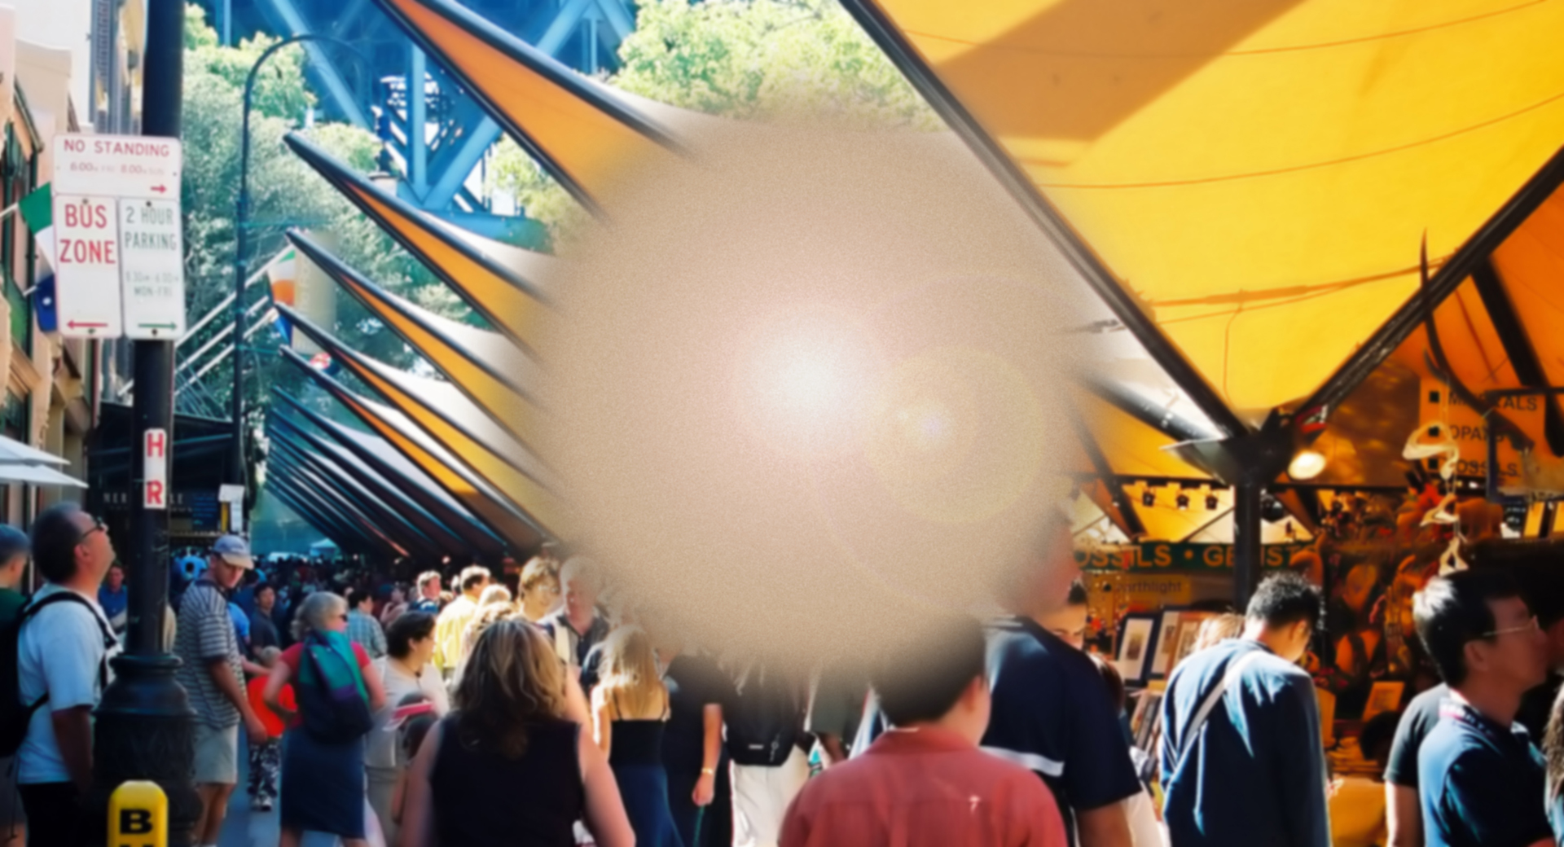
Stargardt’s disease simulation
What is Stargardt’s disease?
Stargardt’s disease is a type of macular degeneration that typically surfaces before the age of 20. It causes a progressive loss of central vision of both eyes, but does not affect peripheral vision.

What are the common symptoms?
Symptoms may include:
- Blurred vision
- Deterioration of central vision
- A central blind spot
- Diminishing ability to perceive colours
- Difficulty adapting from bright sunlight to a dimmer room.

Who is at risk?
This disease is usually an inherited, autosomal recessive disorder. This means, in order to pass Stargardt’s disease to the next generation, both parents must carry the recessive gene.

There is also a rarer dominant form of Stargardt’s disease.
Can Stargardt’s disease be treated?
Unfortunately, there is no known cure for Stargardt’s.

Laser treatment is sometimes recommended, but it will not restore vision or stop the progression of the condition.

How can Vision Australia help?
Vision Australia provides support and services to people of all ages and stages of life who are blind or have vision loss.

We work with people to achieve what’s important to them such as studying, finding or retaining employment, leading an active social life or continuing to do the things they love.

With the support of our professional teams, people who are blind or have low vision can develop their skills and make use of technology and equipment that will enable them to live independently.

Contact Vision Australia
Call 1300 84 74 66
Email info@visionaustralia.org
Website visionaustralia.org
Locations VIC | ACT | NSW | QLD | WA

