Retinitis Pigmentosa

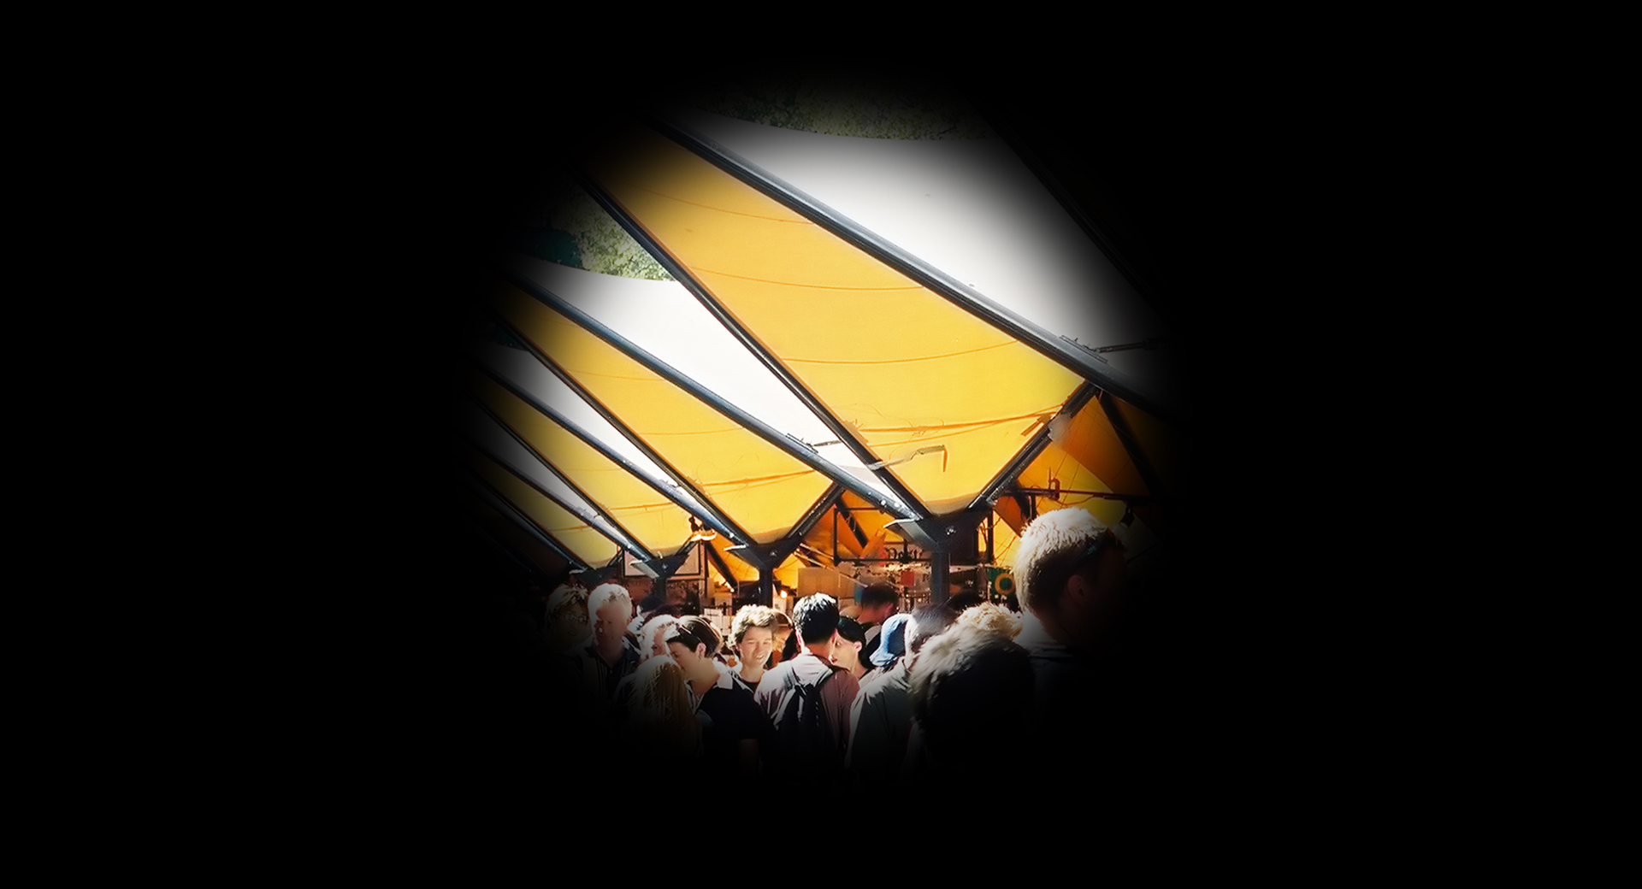
Retinitis Pigmentosa simulation
What is retinitis pigmentosa?
Retinitis pigmentosa (RP) is a genetic eye condition that causes cells in the light-sensitive retina, located at the back of the eye, to degenerate slowly and progressively. The condition can vary greatly.

While many people with RP retain limited vision throughout their lives, others will lose their sight completely.

What are the common symptoms?
Generally, symptoms develop between the ages of 10 and 30 years. Some of the first symptoms may include:
- Difficulty seeing at night (night-blindness) or in dimly lit areas
- A narrowing field of vision
- Light and glare sensitivity

Who is at risk?
RP is an hereditary disease that generally occurs in people that have a family history of the condition.

Can retinitis pigmentosa be treated?
There is currently no standard treatment or therapy for RP.
However, scientists have isolated several genes responsible for the disease and research is being done on stem cell and gene therapy.

How can Vision Australia help?
Vision Australia provides support and services to people of all ages and stages of life who are blind or have vision loss.

We work with people to achieve what’s important to them such as studying, finding or retaining employment, leading an active social life or continuing to do the things they love.

With the support of our professional teams, people who are blind or have low vision can develop their skills and make use of technology and equipment that will enable them to live independently.

Contact Vision Australia
Call 1300 84 74 66
Email info@visionaustralia.org
Website visionaustralia.org
Locations VIC | ACT | NSW | QLD | WA

