Albinism

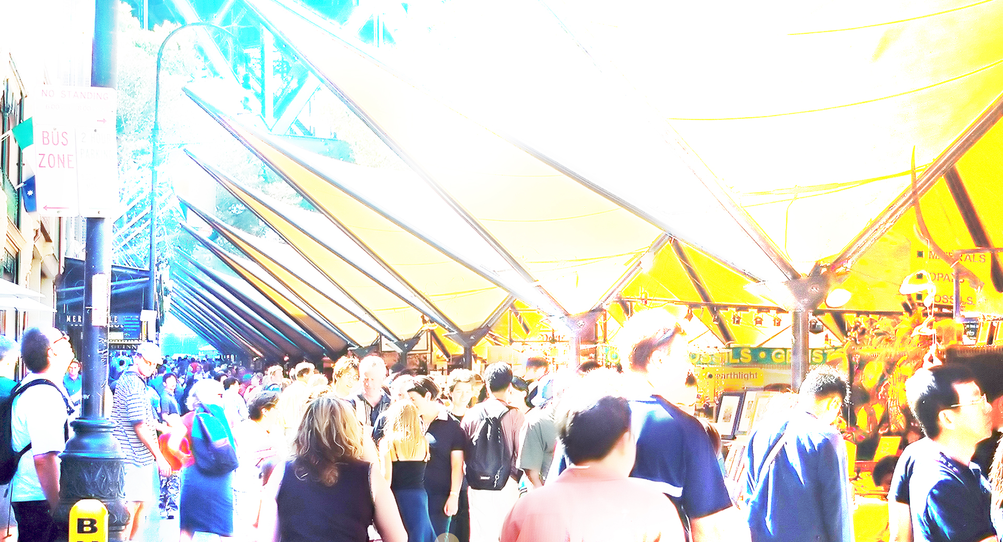

Albinism simulation
What is albinism?
Albinism is an inherited condition. It affects the eyes and skin of some individuals, and only the eyes of others. It results from the body’s inability to produce normal amounts of a pigment called melanin.

What are the types of albinism?

Oculocutaneous albinism:
Both the skin and eyes are affected and can present with varying degrees of pigment. Some people have white hair, little or no pigment in the skin, pale coloured eyes and significant vision impairment. Others with more pigment may have red-brown hair, some skin colour, blue or brown eyes and less severe vision impairment.

Ocular albinism:
People with ocular albinism have pale eyes and vision impairment but the hair and skin are normal or near-normal in colour.

What are the common symptoms?
For both types of albinism, effects on the person’s vision include:
- Macular hypoplasia – an abnormality in the retina resulting in decreased clarity of central vision
- Nystagmus – a rhythmical involuntary to-and fro movement of the eyes
- Photophobia – an intolerance to bright light due to reduced or absent pigment in the iris
- Refractive errors (short or long sight or astigmatism)
- Strabismus (‘squint’ or ‘turned eye’)
Visual pathway anomalies may also be present particularly problems with depth perception.

What other difficulties are caused by albinism?
Skin sensitivity – the effects of albinism on the person’s skin will depend on the amount of pigment present, but all people with albinism are prone to sunburn and skin problems and will need additional protection.

What assistance do children with albinism need?
Children with albinism may need some form of visual aid, depending on the type and extent of the visual condition. Glasses or contact lenses can correct for short or long sightedness or astigmatism.

Older children may need a monocular for distance viewing and some may need large print or a magnifier for reading. All children with albinism benefit from sunglasses and hats to reduce glare and prevent sunburn.

How can Vision Australia help?
Vision Australia provides support and services to people of all ages and stages of life who are blind or have vision loss.

We work with people to achieve what’s important to them such as studying, finding or retaining employment, leading an active social life or continuing to do the things they love.

With the support of our professional teams, people who are blind or have low vision can develop their skills and make use of technology and equipment that will enable them to live independently.

Contact Vision Australia
Call 1300 84 74 66
Email info@visionaustralia.org
Website visionaustralia.org
Locations VIC | ACT | NSW | QLD | WA

