

**ENVOY WILL NOT CHARGE**

If the Envoy will not charge, the most likely cause is the battery is very flat. These instructions reset the Envoy to enable it to charge. A paperclip or similar is required.

1. Put the Envoy on the charger.
2. Hold the Play key down and while doing this turn the Envoy over and gently insert the end of a paperclip into the small pinhole on the back (at lower left of the label).
3. Carefully push it in until it can go no further. This will press the internal Hardware Reset button.
4. The green light should come on and the player will begin to charge. Charge mode is confirmed by the green light flashing slowly.
5. Remove the paperclip and let the Play button go.
6. Leave the player on charge for 3-4 hours.

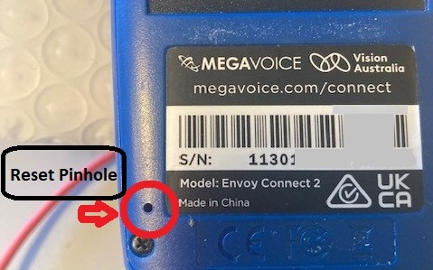

This information is also in the Envoy user guide.

This reset should work for most flat Envoys. If it doesn't work, try putting it in a sunny place to get a solar charge. Sometimes this can wake it up enough to enable charging with the USB cable and electricity.

If neither of these things work, please send the Envoy and charger back to the Library to be checked.

**Things to note**

* It is safe to charge the Envoy overnight.
* The Envoy cannot be overcharged. It will stop charging when it is 100% charged and won’t waste electricity.
* Recharging cannot overheat the Envoy.