# How to do a basic search in i-Access Library

Welcome this video, where we will show you how to run a basic search in the i-Access Library.

## Search

When you log into i-Access, you’ll be taken to the Home screen. The Home screen shows the basic search with the heading “Search the catalogue”.

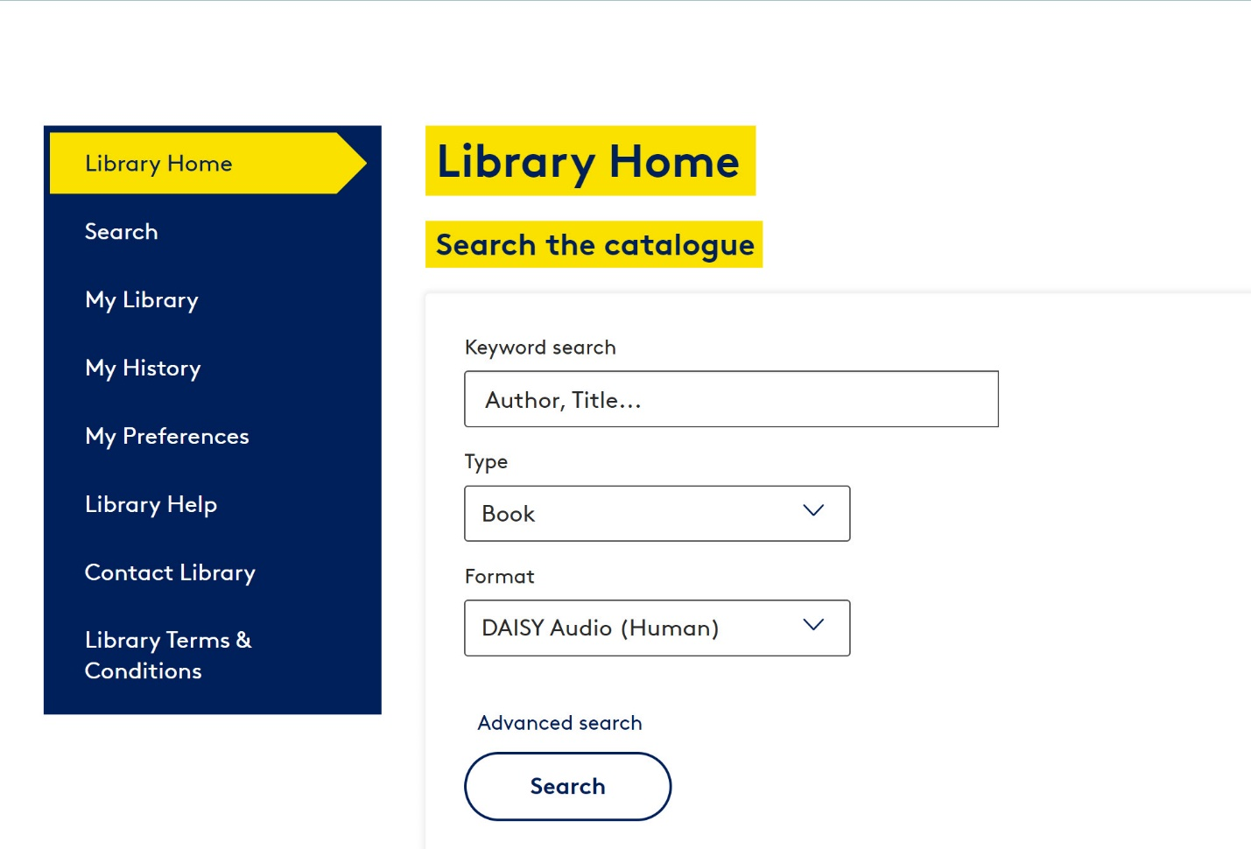

This is where you can search for the library resources you want to read.

The first box is a keyword search. Enter the key words for your item to search across the author, narrator, title, series title, and synopsis or description.  
  
For example, I want to look for books in the Harry Potter series

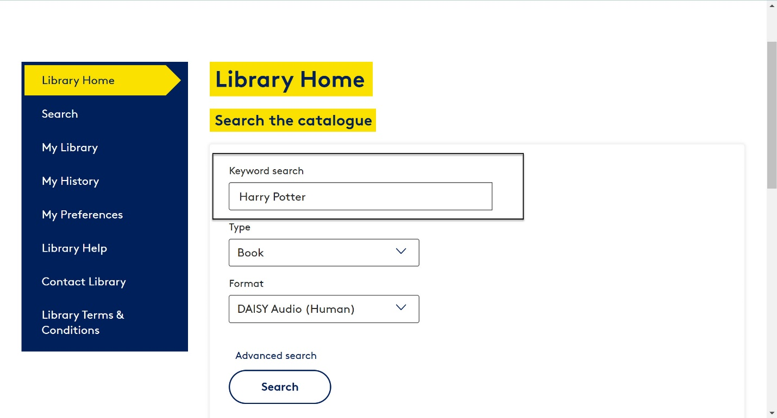

If you want to narrow down your search, you can select a Type of publication to search for. This is a new feature in i-Access.

There’s a drop-down list, and if you click on the downward facing arrow, you can see that the Type options are book, picture book, magazine, newspaper, podcast, and music (that is music braille).

For my Harry Potter search, I’m searching for books.

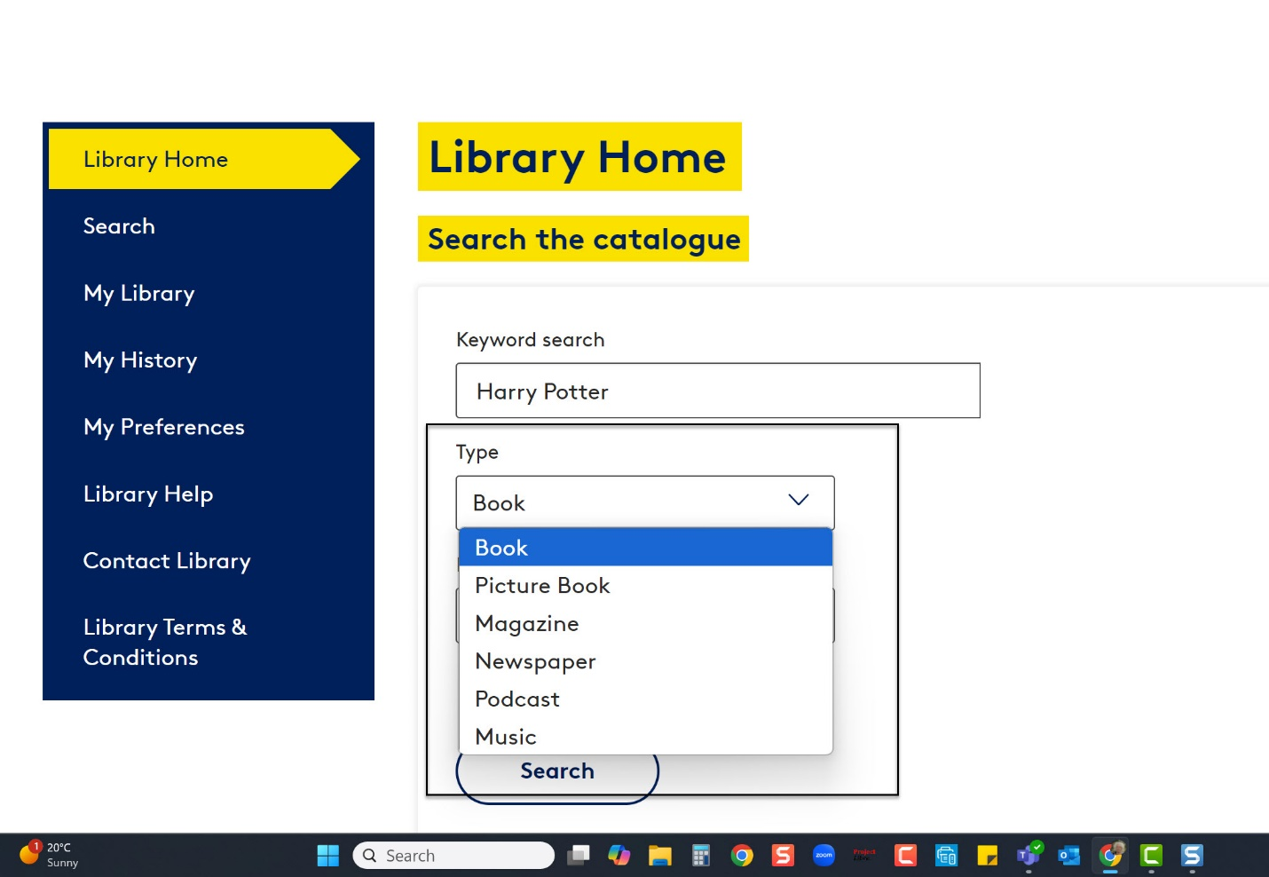

You can further narrow down your search by selecting what format you want. Again, there’s a drop-down list, and the downward facing arrow will show you that the available formats in our collection are Braille, eBraille, Daisy Full Text (Audio), Daisy Audio (All), Daisy Audio in human voice, and Daisy Audio in synthetic voice.

For my Harry Potter search, I’m going to choose Daisy Audio (All)

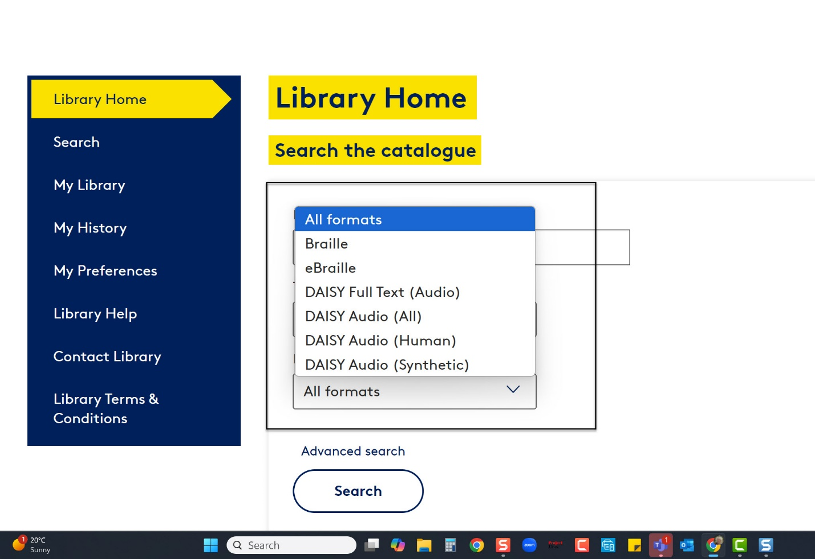

Once you’ve entered all your search terms, you can click the Search button to conduct your search.

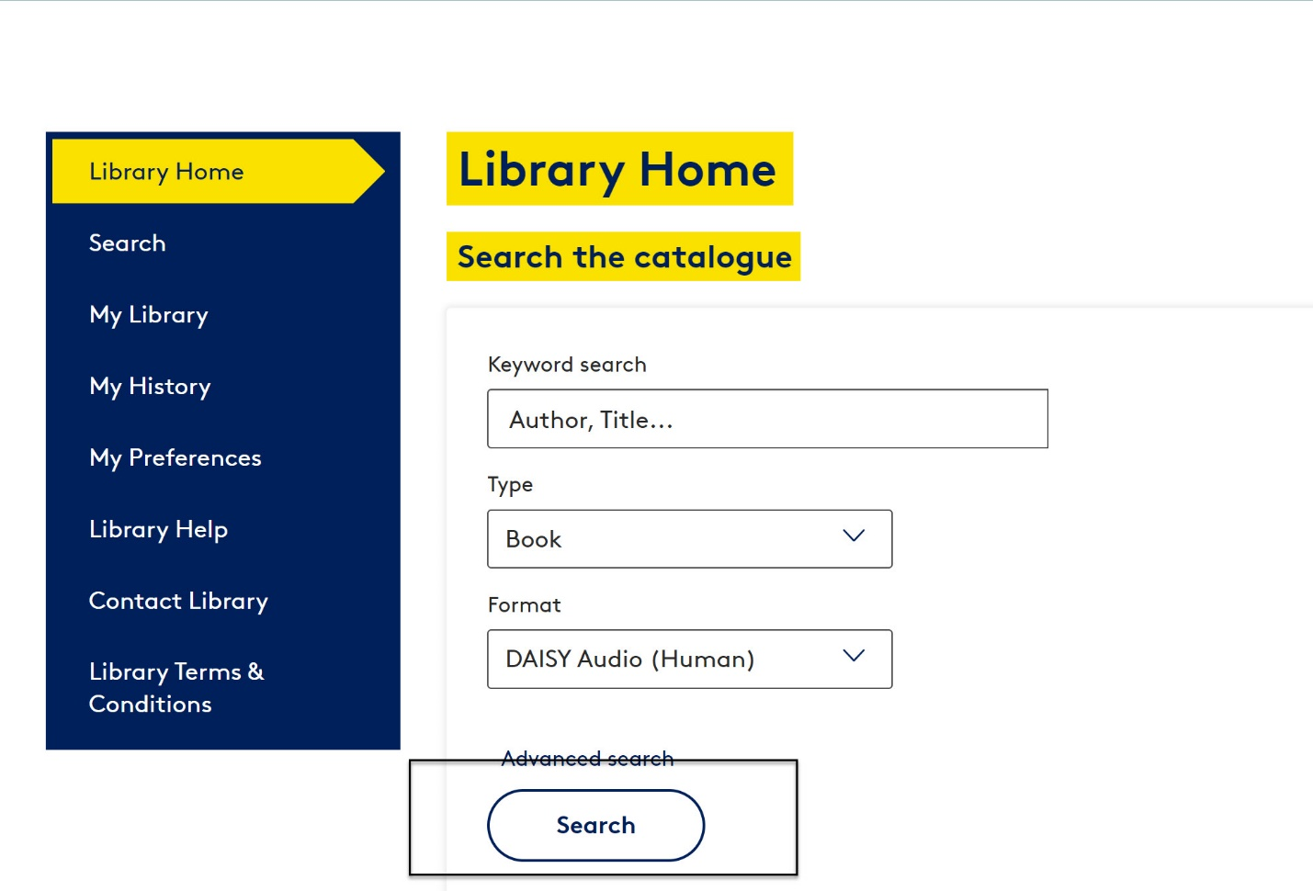

The screen will refresh, and the Search Results will show below the Search button.

You can see that for my search, we found sixteen books for my key words Harry Potter.

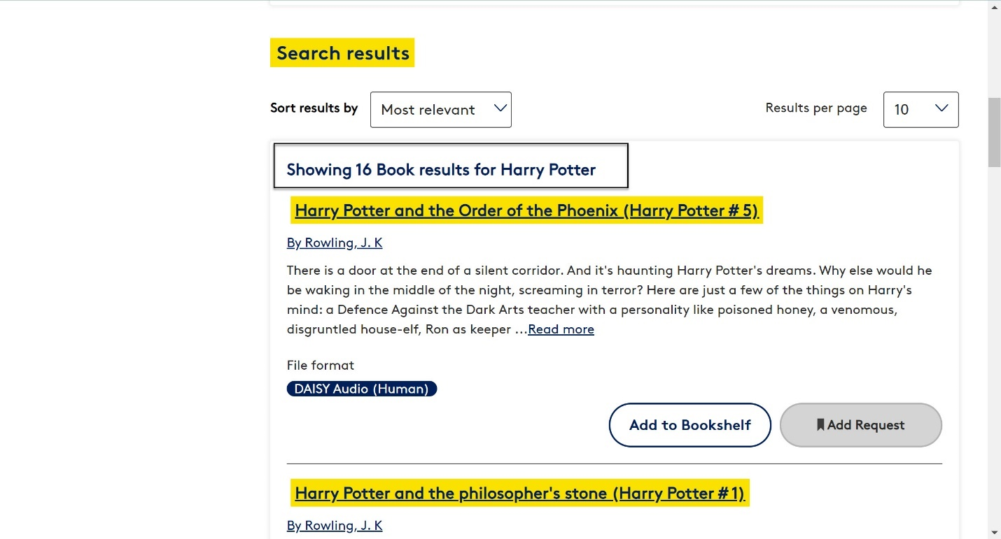

The search results on this screen are sorted by Most Relevant, which is the default, but I can use the downward facing arrow to change this to Newest, Author, or Title.

My search results show ten results per page. Again, I can use the downward facing arrow to change this, to see twenty results per page if I want to.

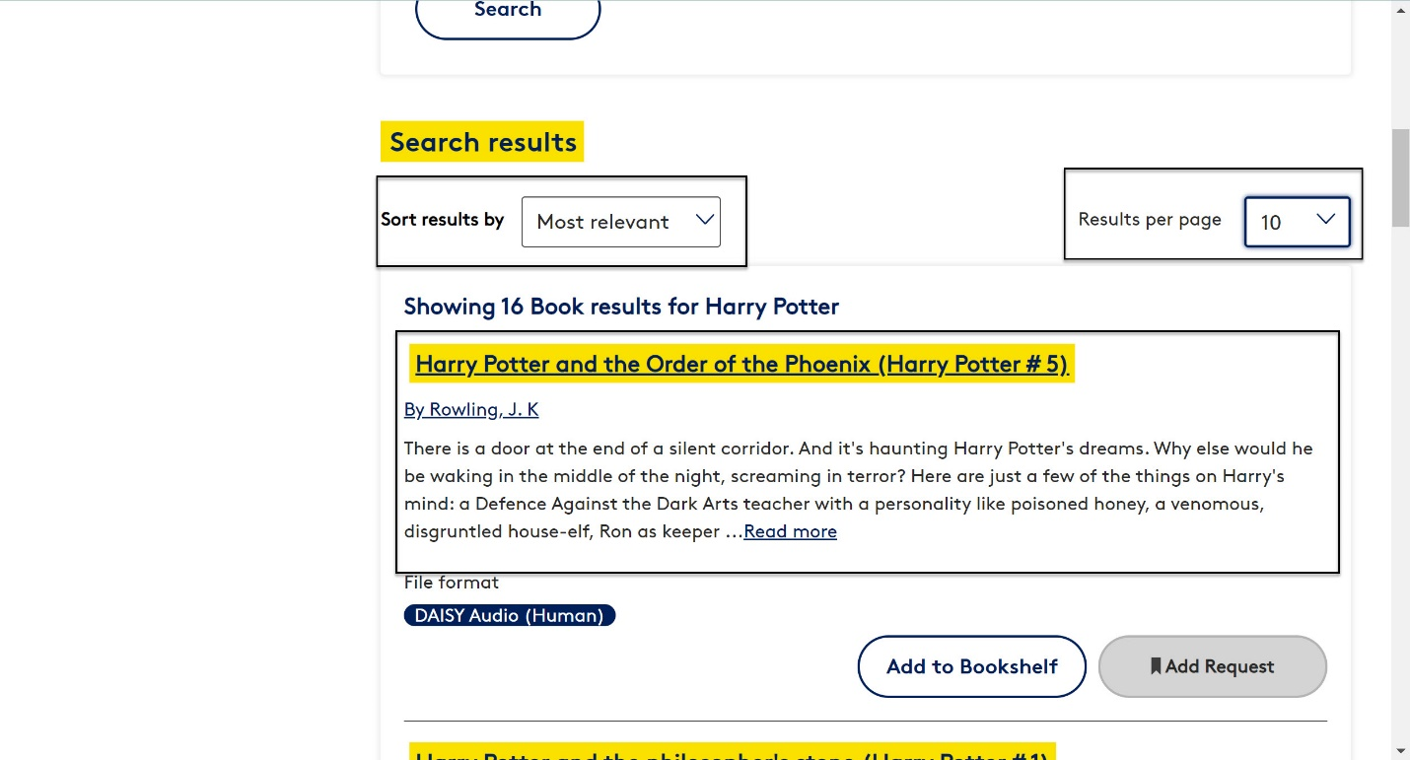

My search result gives me the title of the book. In this case, it’s Harry Potter and the Order of the Phoenix. It tells me the author, and it gives me a brief synopsis or description of the book.

My search result also tells me what Format it is in. In this case, it is Daisy Audio in a human voice. If my book has more than one format available, each format will appear in a different search result. This is a new feature in i-Access, and it makes it easier for you to choose the format that you want.

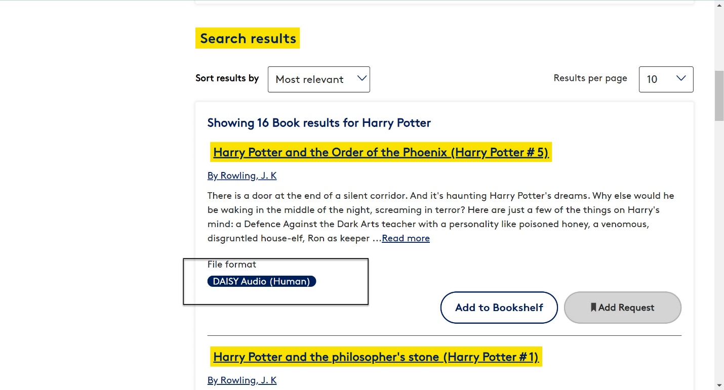The search result also includes some action buttons. In this case, there’s an option to add my book to My Bookshelf, or, to add it to my Request List. These buttons will change, depending on the format that you have selected. For example, if I were searching for newspapers, the buttons would show Subscribe and View all issues.

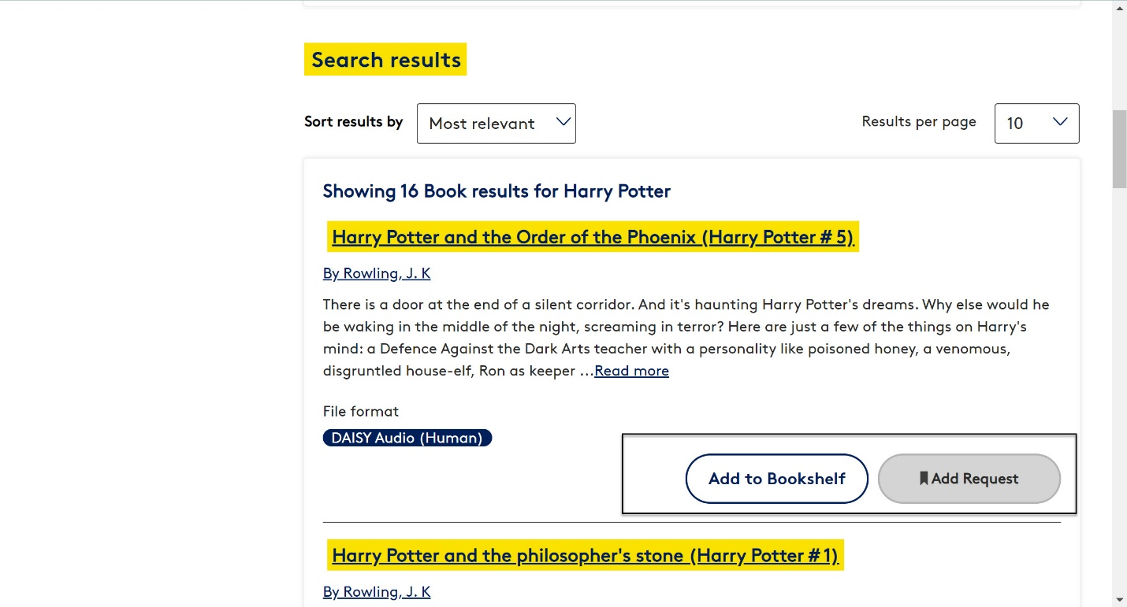

If I want to see more details about the book, I can click on the Title to be taken to the Item Details screen.

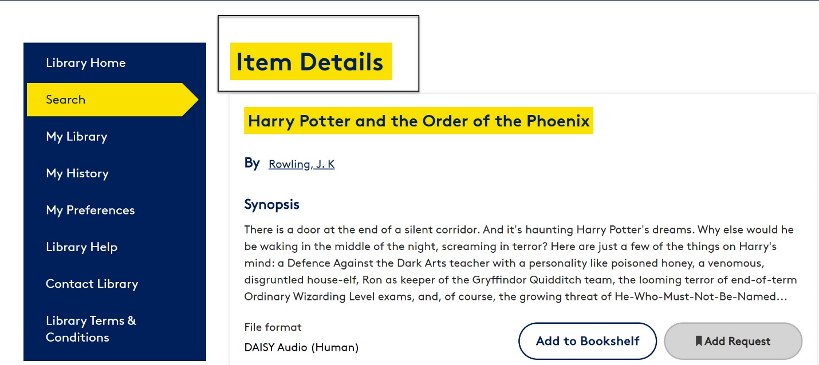

The Item Details screen contains all the basic information about the book, but as I move down the page, it also contains additional information such as the duration of the recording or who the narrator is, in this case, Stephen Fry.

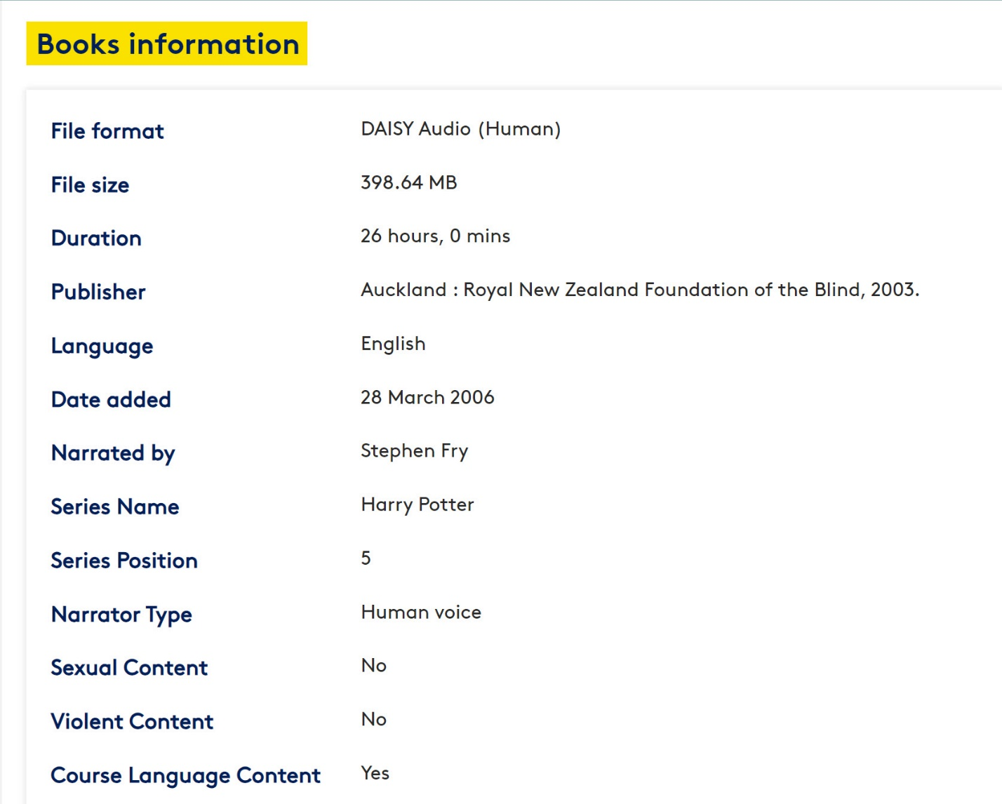

To get back to my search results, I just need to click on the link called “Return to previous page”.

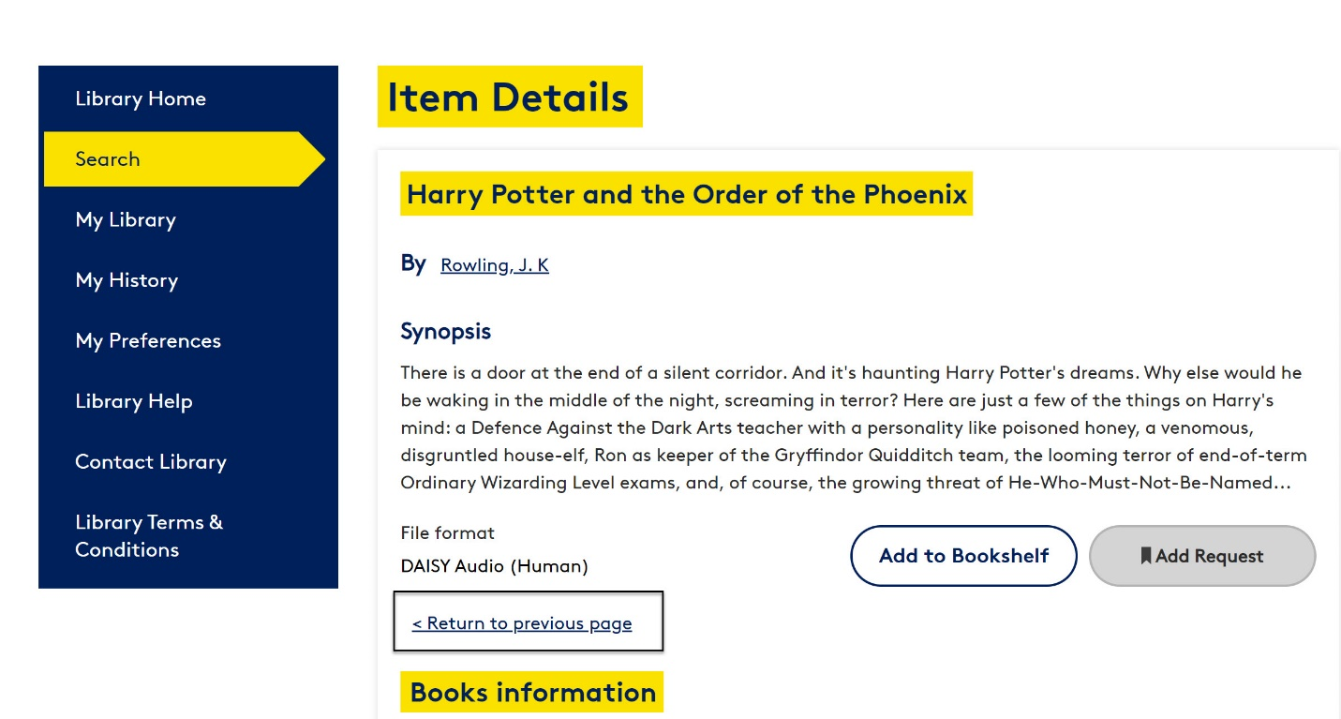

So that’s how to conduct a basic search in the i-Access Library.

Thank you for watching this video, on how to run a basic search in the i-Access Library.

You can find more information and help in the i-Access Library User Guide, which is in i-Access under the Library Help menu.

You can also call Vision Australia on 1300 847 466 or email the library at [VisionAustralia.Library@visionaustralia.org](mailto:VisionAustralia.Library@visionaustralia.org)