Braille tactile street signage survey

Introduction
City of Melbourne is investigating the current perception and usage of braille tactile street signage that is installed at intersections within the central city.
These signs are installed on the traffic poles above the audible crossing buttons. They are blue with white raised lettering and feature braille dot information about intersecting road names and building numbers.
The survey should take around 10 minutes to complete. Some questions are yes/no answers, some have multiple answers, while others will be worded answers that you will need to write as sentences.
This survey is intended to inform future improvements to our signs and navigation of the city.
If you would prefer to do the survey over the phone, please email Martin.Whittle@melbourne.vic.gov.au to organise a time to call.

Privacy
City of Melbourne is committed to protecting your privacy and your personal information will not be collected or used as part of the survey's results.
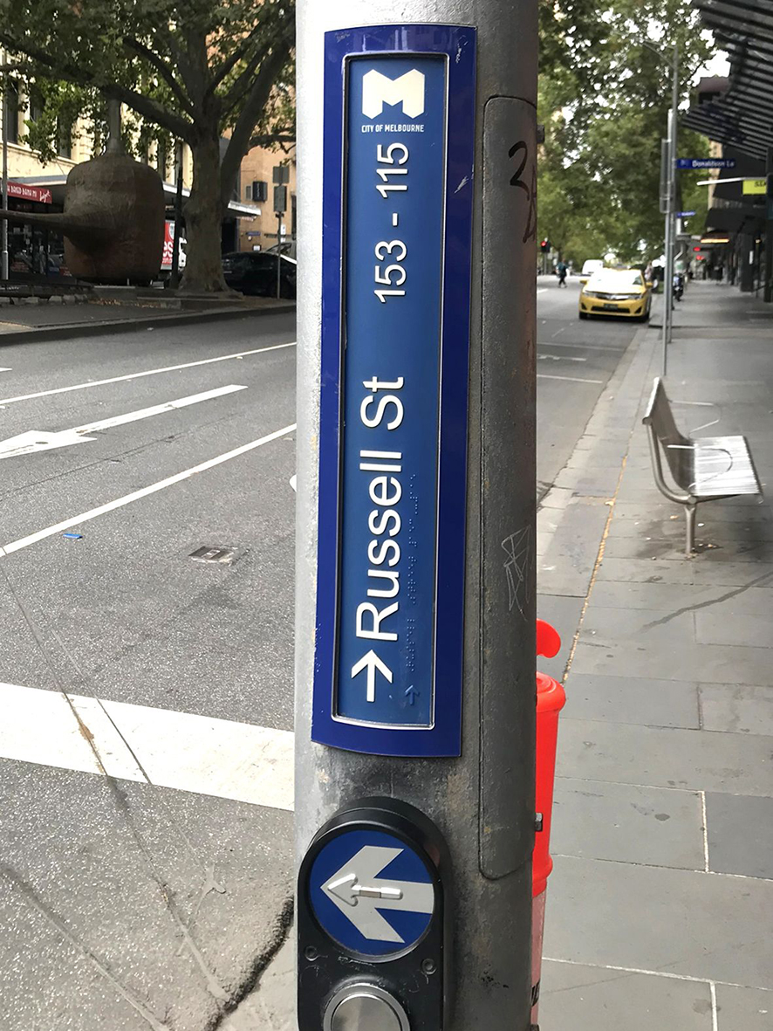

Question 1.
Do you identify as a person who is totally blind, legally blind or has low vision.
Your answer:

Question 2.
What is your age?
Your answer:

Question 3.
Do you know that City of Melbourne has braille tactile street signage at intersections within the central city?
Yes/No (if no, please feel free to go to Question 11).
Your answer:

Question 4.
Do you use the braille tactile street signage in the city?
Yes/No (if no please specify why not and then feel free to move to Question 11).
Your answer:

Question 5.
How often do you use the City of Melbourne braille tactile street signage?
Always, Usually, Sometimes, Rarely, Never (if rarely or never, please specify why not)?
Your answer:

Question 6.
What important information do you want from these braille, tactile signs? Eg intersecting road information, road ahead information, building numbers, other?
Your answer:

Question 7.
How easy are the braille tactile street signs to find?
Very Easy, Easy, Somewhat Easy, Somewhat difficult, Very difficult. (If you answer Difficult please specify why)?
Your answer:

Question 8.
Do you find the existing braille tactile street signage useful?
Very useful, Useful, Somewhat useful, Not useful. (If you answer not useful please specify why)?
Your answer:

Question 9.
What improvements would you suggest to the current braille tactile street signage?
Your answer:

Question 10.
Do you have any other comments regarding City of Melbourne’s braille tactile street signage?
Your answer:

Question 11.
What other things do you use to help navigate through the city?
(Eg technology, tactile indicators, audible buttons, auditory or sensory clues, etc.).
Your answer:

Question 12.
Do you use other types of signage to navigate the city?
Yes/No (if yes please specify types)
Your answer:

Question 13.
Do you believe the City of Melbourne is an accessible city for people who are blind or have low-vision?
Yes/No (if no please specify why not)
Your answer:

Question 14.
What else could the City of Melbourne do to improve your navigation around the city?
Your answer:

Question 15.
What reasons do you have for coming into the city and generally where do you visit?
Your answer:

That’s the end of the survey. Thank you for your time and responses. If you have any questions for us, please feel free to ask them here and supply your email and we will get back to you as soon as possible.
Your questions:

Thank you

