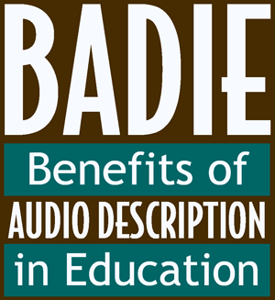
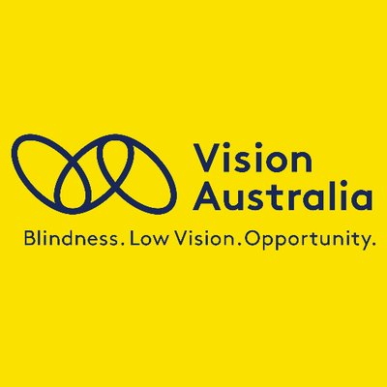

Sourcing Audio Described Content in Australia

Films and TV programmes
If you're interested learning about audio described movies currently available on streaming services such as Netflix or Stan, Vision Australia has created a super helpful list which you can access here: https://www.visionaustralia.org/community/news/2020-05-07/audio-described-movies-streaming-services

Audio Description in Australia also has a handy guide. You can access this here: https://audiodescriptionau.com.au/?page_id=560
Vision Australia provides a combined ABC and SBS TV guide (Word) listing all audio described shows across both channels for the next two weeks. You can access this here:
https://www.visionaustralia.org/community/events/audio-description-services
Each channel’s own programming schedules can be you accessed through these links: ABC and SBS.
https://www.abc.net.au/tv/audiodescription/
https://www.sbs.com.au/aboutus/audio-described-programming
In order to access audio description on ABC and SBS, you need to turn on the features on your TV. Vision Australia’s audio description team have provided this list of instructions to guide you through the process: https://www.visionaustralia.org/community/news/2020-05-07/audio-described-movies-streaming-services

The Cinema
Vision Australia has the following guide to accessing audio description at the cinema: https://www.visionaustralia.org/community/events/audio-description-services/at-the-cinema
Audio Description in Australia also has a great guide to accessing audio description at the cinema: https://audiodescriptionau.com.au/?page_id=413

Theatre and Galleries
Here are some places you can use to find audio described theatre and exhibitions in your area:

Audio Description provided by Vision Australia: https://www.visionaustralia.org/community/events?term=1521&state=All
Media Access Australia provides the following overview: https://mediaaccess.org.au/cinema-the-arts/audio-description-in-the-arts
It’s also worth contacting your local theatre to find out what their audio described offerings include.

Melbourne Fashion Festival
For the past couple of years, Vision Australia has worked with the Melbourne Fashion Festival to audio describe some of their runways. Keep up to date on what’s coming up here: https://www.visionaustralia.org/community/events/audio-description-services

You can access a recorded runway from 2021 here: https://melbournefashionfestival.com.au/runway-3-ad

Educational Content

The US-based Described and Captioned Media Program (DCMP - co-sponsor with the American Council of the Blind's (ACB) Audio Description Project of the original BADIE initiative) have approximately 1,900 audio described titles that are available to anyone regardless of location (no membership and no sign-up required): https://dcmp.org/topics?nm=1

If you are trying to find a particular title or type of content and you can’t find it using the above links please contact BADIEAU@Visionaustralia.org and we’ll see if we can help signpost you in the right direction! And if you have any questions about the BADIE-AU initiative please drop us a line at the same address.

