Emotional Support –
Quality Living Groups

Contents
What are Quality Living Groups? 2
How do they work? 2
What type of groups are on offer? 2
Eligibility and cost? 3
Why should I join? 3
How do I join? 4
What will I know after finishing the course? 4
Testimonials: 5
Vision Australia can help you connect with others. 7

Being diagnosed with a vision condition can be life-changing. It often comes with minimal help and many are left asking themselves, ‘what now?’.
At Vision Australia, we think it’s vitally important for people who are newly diagnosed to connect with others who are going through similar situations.
Having an honest forum to discuss the issues and emotions associated with vision loss, while listening to others talk about how they have coped and built resilience, is a proven way to improve someone’s mental health and general wellbeing.

What are Quality Living Groups?
Quality Living Groups are Vision Australia’s emotional support groups for people who have recently been diagnosed with a vision condition.
They are confidential, safe and supportive forums to discuss the issues relating to the impacts of vision loss.
Coordinated by people with lived experience, the groups also provide useful practical knowledge – like adjusting things at home, learning to navigate around your neighbourhood, understanding the latest assistive technology options and help with maintaining friendships and social ties post diagnosis.

How do they work?
- 2.5 hours commitment each week over-the-phone (or in-person at select locations)
- Eight-week course led by participants’ needs
- Eight participants maximum per group
- Facilitated by trained coordinators, with special expert guests on certain topics
Group participants decide on the topics which best meet their needs and those topics fill the course.
Each group is unique, which is why some people have signed up to multiple courses over the years.

What type of groups are on offer?
Our emotional support groups are varied and cover:
- Adult groups
- Seniors groups
- Parents groups
- Carers groups
- Education or employment focused groups
The groups run regularly throughout the year and some can be taken after hours for working people.
They are conducted over-the-phone and on occasion in-person at a Vision Australia office.
Regular topics covered in the groups:
- Getting out and about confidently
- Staying independent with everyday tasks
- A brave new world of technology
- Staying socially active & enjoying personal interests
- Relationship changes, communications
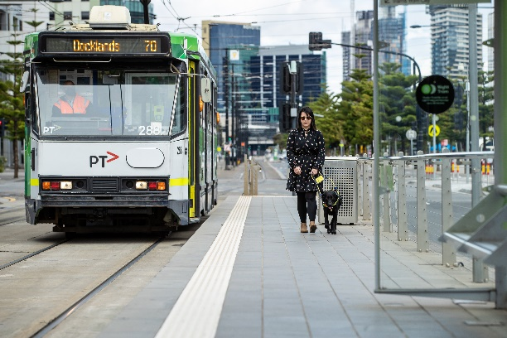

Eligibility and cost?
The program is open anyone who has blindness or low vision or is a carer.
The program’s cost is covered by your NDIS or My Aged Care plan if you’re an older adult.
If you don’t have any of these services, the program is still open to you, just call 1300 84 74 66 to find out more.

Why should I join?
Many people who have joined a Quality Living Group say that it has been one of the best things they’ve done since experiencing vision loss.
They’ve been able to share their ideas about making life easier, talk about barriers they’re facing, feel the support of others who really understand, and often make lifelong friends.

How do I join?
Register your interest here: visionaustralia.org/quality-living
Or scan the QR Code beneath:
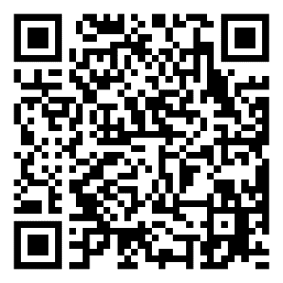

What will I know after finishing the course?
While everyone’s experience is unique, some things you can gain from the group include:
- Develop strategies to cope, build resilience and confidence
- Learn how others who are blind or have low vision handle everyday tasks
- Learn what technologies are available to help you (ie white canes, smartphones to help you read menus or identify colours, magnifiers, library tools etc.)
- Discuss ways to talk about your eye condition with friends, family and strangers
- Learn ways to handle negative questions
- Overcome isolation
- Develop a social support network and make new friends

Testimonials:
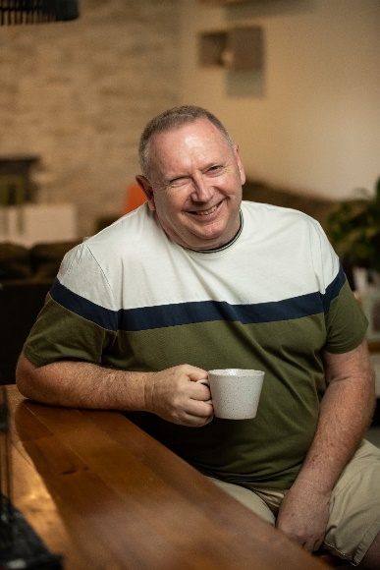

Paul Hedley – 59, peer-support volunteer & former participant
“When I lost my eyesight I felt like I was the only person going through what I was going through.
The Quality Living Groups gave me the opportunity to interact with other people from different walks of life that were going through the exact same thing as me.
When you first start, you’re emotionally very raw. Most people are crying, they’re upset, they’ve lost or are losing their vision and they don’t know what to do. After eight weeks I’d say 80 to 90 per cent of people are just different. They’re so happy and confident and they have a way forward with their lives.
I did two Quality Living Groups and after both of them I just felt like someone had filled up my tool box with a whole bunch of really useful tips and strategies to deal with my vision loss. The more time you can spend with people who are in a similar situation, the better. You start to develop your self-esteem and your confidence.
The groups are about being kind to yourself and allowing yourself the time to learn things that you need to learn, and also allowing yourself to make mistakes. Seek out that advice, it’ll be one of the best things you can do for yourself.”
Scan to hear Paul’s story
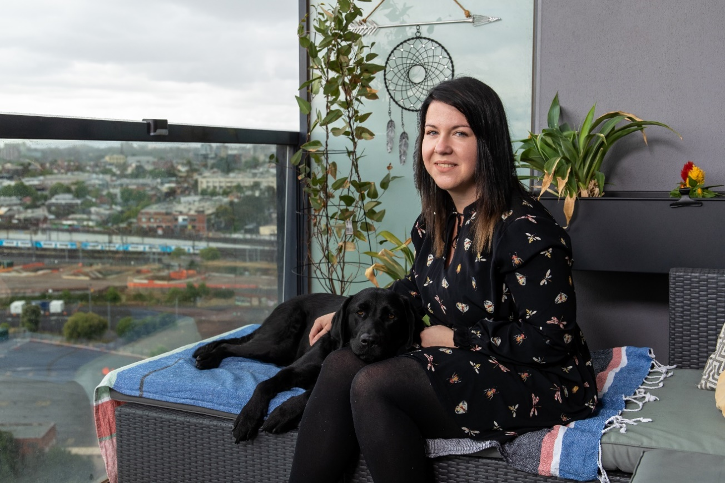

Brittnee Watson, 27, former Quality Living Group participant
“The Quality Living Group honestly made me feel like there was life after blindness.
That I wasn’t going to be just stuck at home with my mum looking after me the whole time that I could live by myself, get a job and do anything I really wanted to do without the fear of being looked after the whole time.
The group came at a really pivotal time in my life. I had just started the course when I had my first experience of going completely blind. I had always rested on having a little bit of vision left to get me around, but this time, I had nothing. It was really scary. But I was able to share my anxieties and feelings as they were happening with a really understanding group. They were able to encourage me and give me immediate tips and tricks to make my life easier.
You realise that no question is a stupid question. That if you’re thinking it that somebody else is thinking it too. If you needed to ask for advice, it was easy. The Quality Living Groups teach you to use blindness to your benefit.”
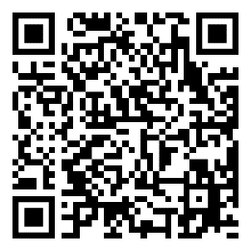
Scan to hear Brittnee’s story

Vision Australia can help you connect with others.
Call our Helpline on 1300 84 74 66
Read more about Quality Living Groups here:
visionaustralia.org/qualityliving

Find out more about Vision Australia’s
visionaustralia.org
Email: info@visionaustralia.org
facebook.com/VisionAustralia
twitter.com/visionaustralia

