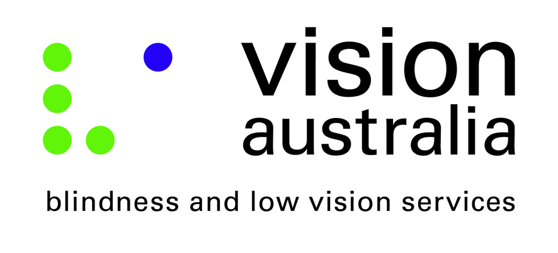

Vision Australia’s submission to the Department of Justice and Regulation toward improving equality by legislative reform to the Juries Act 2000 (Vic)

Email: anqelica.quz@iustice.vic.ciov.au

Angelica Guz
Senior Legal Policy Officer
Dispute Resolution, Civil Justice
Department of Justice and Regulation
(03) 8684 0856

Response approved by: Ron Hooton
Chief Executive Officer

Response submitted by: Kate Begley, Policy Advisor
kate.begley@visionaustralia.org
03 9864 9415

Summary

Vision Australia welcomes the opportunity to make a submission to the Department of Justice and Regulation to address aspects of the Juries Act 2000 (Vic) that exclude people who are blind or have low vision from participating in the administration of justice as a juror.

Vision Australia supports the NSW Law Reform Commission’s recommended legislative changes to the Juries Act 2000 (Vic).

We believe that people who are blind or have low vision should be able to exercise their rights as citizens on an equal par to the rest of the community. Individuals must not be prevented from appearing on juries solely on the basis of their vision loss.

It is also vital that the blindness community participate in criminal and civil trials as jurors so as to represent the estimated 84,000 people in Victoria who are blind or have low vision. Ideally a jury should consist of a cross section of the community including a variety of age groups, ethnicities, genders and disabilities.

The UN Convention on the Rights of Persons with Disabilities (CRPD) at Article 29; Participation in political and public life, states:

States Parties shall guarantee to persons with disabilities political rights and the opportunity to enjoy them on an equal basis with others, and shall undertake to:

(a) Ensure that persons with disabilities can effectively and fully participate in political and public life on an equal basis with others, directly or through freely chosen representatives, including the right and opportunity for persons with disabilities to vote and be elected.”

Laws that inhibit the civil rights of people who are blind or have low vision are discriminatory and we believe that they must be amended accordingly.

Recommended amendments to legislation to enable people who are blind or have low vision to serve as jurors
We believe that there must be legislative reform that enables people who are blind or have low vision to serve as jurors.
Schedule 2 to the Juries Act 2000 (Vic) lists persons who are ineligible to serve as jurors for the purposes of section 5(3) of the Act. Clause 3(a) excludes a person who 'has a physical disability that renders the person incapable of performing the duties of jury service’.
Clause 3(a) must only exclude people with a physical disability if reasonable adjustments do not support that individual’s capacity to perform their duty as a juror.

Below are examples of reasonable adjustments that could be offered by the courts to assist people who are blind or have low vision to serve as jurors:

- The modification or provision of equipment, for example adaptive technology or other aids to support the juror’s ability to access evidence.
- The alteration of court procedures, like the allowance of additional time for the juror to access evidence.
- Court documentation to be supplied in accessible formats like Braille, large print or electronic format.
- The appointment of an assistant who can guide the juror and describe visual evidence to the juror who is blind or has low vision.
- The juror should be positioned in seating that allows them to maximise their vision (if they have low vision rather than blindness).
- The courtroom must be free from unnecessary obstacles and meet standards of accessibility for the juror.

Concerns relevant to a person who is blind or has low vision if they were permitted to serve as jurors and how these concerns can be accommodated

- Trial proceedings may take longer than usual if the person who is blind or has low vision requires additional time to access information.

- The additional time that people who are blind or have low vision require to access information is not often substantially longer than the rest of the community and so is unlikely to significantly disrupt the usual timings of a trial.
- Provision of evidence or court documents prior to court sessions, where appropriate, could allow jurors who are blind or have low vision, to access information without extending proceedings.

- There is a Common Law principle that a non-juror is not permitted as a thirteenth person in the jury room (Section 2.1.2). This principal may be of concern when appointing a juror with vision loss if the juror requires a person, who is not on the jury, to assist them.

- Rather than engaging an additional person, a ‘thirteenth person’ another jury member could volunteer to assist the juror who is blind by guiding them when necessary and by describing visual evidence to them when necessary. The precedence for this recommendation occurred in New Zealand in 2006 when a person who is blind participated in a four day trial as a juror. Description of the visual exhibits that were presented to the jury was required and a fellow juror volunteered to verbalise the visual evidence to him for the duration of the trial.
- If a specialist assistant is needed that person could be required to take an oath that they will not participate in deliberations and also provide a written statement afterwards that they had not participated. As recommended by the Victorian Law Reform Commission (VLRC) in its 2014 Report "Jury Empanelment" “interpreters or stenographers allowed by the trial judge to assist the deaf or blind juror should be permitted in the jury room during deliberations without breaching jury secrecy principles, so long as they are subject to and comply with requirements pertaining to the secrecy of jury deliberations.”

- People who are blind or have low vision will not be able to accurately assess the appearance and demeanour of the person on trial.

- While it is fair to say that body language may be used to judge a witnesses testimony, body language and facial expressions can be misleading and misconstrued by sighted people: there is no universal standard which states that certain visual cues point to untrustworthy behaviour. It is a false assumption to preclude the selection of jurors with blindness or low vision on these criteria, as the ability to ‘accurately assess the appearance and demeanour of the person on trial’ is not one that can be fairly applied to, or measured in, sighted jurors. Additionally:
- The ability to interpret personality traits and demeanour through other senses cannot be underestimated. People who are blind or have low vision are able to form reliable opinions and judgements in their daily life about the people they interact with based on other senses.
The presence of many people who are blind or have low vision in prestigious professions proves that other senses can be utilised to great effect to assist with character judgements. For example; in a court setting, tone and tenor of voice is an important guide for people who are blind or have low vision in identifying the demeanour of the person on trial.

Training required for judges, lawyers and court staff provided by Vision Australia
Jurors who are blind or have low vision would require certain supports and adjustments. Judges, lawyers and court staff would need to undergo basic training in the event that a blind or low vision juror is enlisted. Training would involve:

- Learning how to safely and respectfully guide someone who is blind or has low vision.
- People who are blind or have low vision require visual information, for example writing on a white board in a meeting, to be articulated. Court staff, judges and lawyers would need to articulate all visual material that they are referring to during trial proceedings.
- When in a meeting scenario, people who are blind or have low vision will not know who is in attendance unless the people present say their names aloud. This roll call should be done at the start of any meetings that jurors are attending.

Vision Australia is the largest provider of services to people who are blind, deafblind, or have low vision in Australia.

We offer training to companies and organisations on protocol when in the company of a person who is blind or has low vision.

Vision Australia will assist any Victorian court with the necessary training, accessibility assessment, provision of specialised equipment and conversion of documents to accessible formats to enable a person with severe vision loss to participate in the justice system as a juror.

About Vision Australia

Vision Australia is the largest provider of services to people who are blind, deafblind, or have low vision in Australia. It was formed through the merger of several of Australia’s most respected and experienced blindness and low vision agencies.

Our vision is that people who are blind, deafblind, or have low vision will increasingly be able to choose to participate fully in every facet of community life. To help realise this goal, we provide high-quality services to the community of people who are blind, have low vision, are deafblind or have a print disability, and their families. The service delivery areas include:

- early childhood
- aids and equipment
- orientation and mobility
- employment
- accessible information (including library services)
- recreation
- independent living
- Seeing Eye Dogs
- advocacy, and working collaboratively with Government, business and the community to eliminate the barriers our clients face in making life choices and fully exercising rights as Australian citizens.

Vision Australia has gained unrivalled knowledge and experience through constant interaction with our 27,500 clients and their families, and also through the involvement of people who are blind or have low vision at all levels of the Organisation. Vision Australia is therefore well placed to provide advice to governments, business and the community on the challenges faced by people who are blind or have low vision fully participating in community life.

We have a vibrant client consultative framework, with people who are blind or have low vision representing the voice and needs of clients of the Organisation to the Board and Management.

Vision Australia is also a significant employer of people who are blind or have low vision, with 14% of total staff having vision impairment.

Vision Australia also has a formal liaison arrangement with Blind Citizens Australia (BCA) through a Memorandum of Understanding for a number of purposes, including collaboration, so that Vision Australia’s systemic advocacy and public policy positions are, wherever practicable, consistent with the programs and policies of Australia's peak body representing people who are blind or have low vision.

