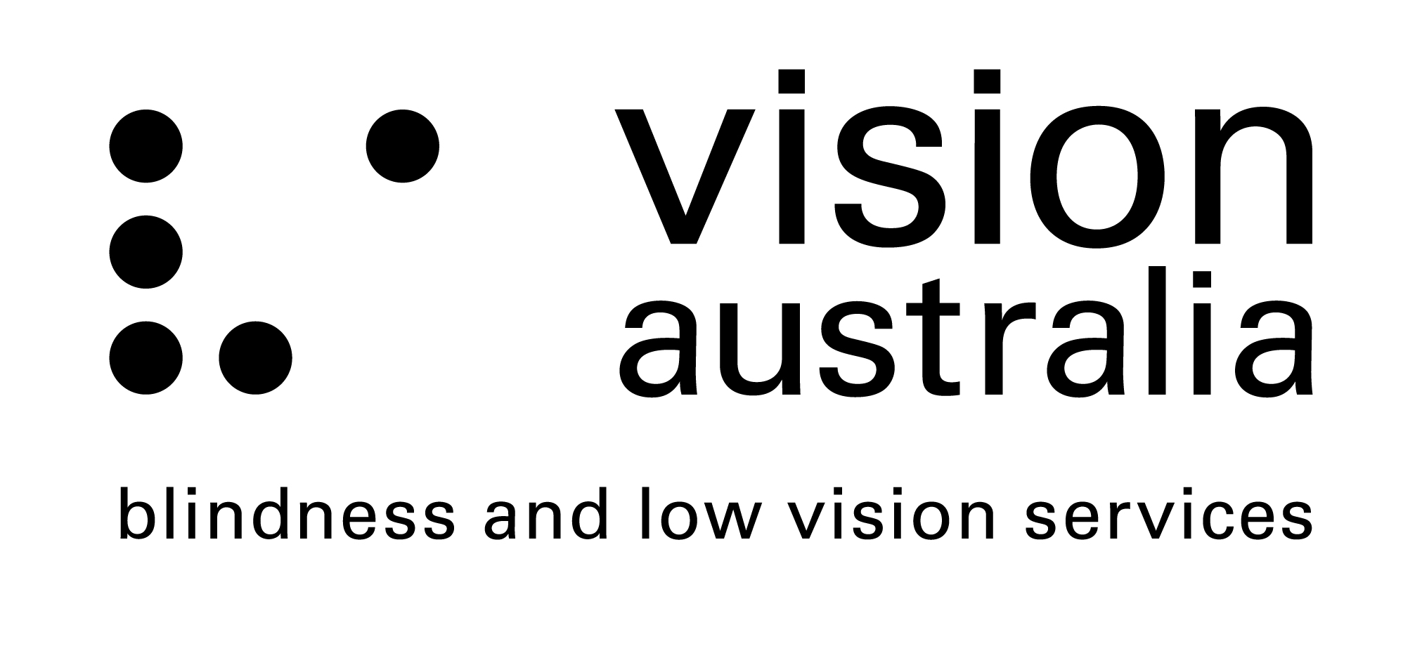
20 March 2014

Committee Secretary
Senate Education and Employment Committees
PO Box 6100
Parliament House
Canberra ACT 2600

Email: eec.sen@aph.gov.au

Inquiry into the role of Technical and Further Education system and its operation

Submission to: Senate Education and Employment Committees
Response submitted by: Maryanne Diamond, General Manager, Advocacy and Engagement, Vision Australia

INTRODUCTION
Vision Australia is pleased to have the opportunity to provide input into the Inquiry into the role of the Technical and Further Education (TAFE) system and its operation, and to draw attention to the unique needs of students who are blind or have low vision in the TAFE system.

In this submission we respond specifically to the following Terms of Reference:
- the development of opportunities for Australians to improve themselves and increase their life and employment prospects;
- the delivery of services and programs to support….disadvantaged individuals to access training and skills and through them a pathway to employment; and
- the operation of a competitive training market.

SUMMARY
- The TAFE environment offers people who are blind or have low vision a supportive environment in which to gain a well recognised qualification.
- Well established and well resourced institutions such as TAFE are more able to provide dedicated diversity, disability and other support services to students who are blind or have low vision, including the ability to make reasonable adjustments to enable students to meet the inherent requirements of their course.
- Public funding of TAFE must be both preserved and increased to ensure that people who are blind or have low vision do not experience barriers to accessing education and meaningful employment.

ABOUT VISION AUSTRALIA
Vision Australia is Australia’s largest provider of services to people who are blind or have low vision. We currently provide services to over 30,000 clients across 28 office locations throughout Queensland, New South Wales, the Australian Capital Territory, and Victoria. Clinics are also held in 29 other locations, in addition to mobile outreach services in the Northern Territory and Tasmania.

Our vision is that people who are blind or have low vision will increasingly have the choice to participate fully in every facet of life in the community. To help realise this goal, we are committed to providing high-quality services to the community of people who are blind or have low vision, and their families. These services include education and employment support, advocacy, and technology services.

TERMS OF REFERENCE
The role played by TAFEs in the development of opportunities for Australians to improve themselves and increase their life and employment prospects

Our work with blind and low vision clients tells us that the nature of the TAFE environment, with its small class sizes, engagement with teaching staff, support services, and opportunities for flexible learning, can suit many people with disabilities and diverse needs.

TAFE offers students the opportunity to develop practical skills, knowledge, and experience, culminating in a recognised qualification. In Australia, qualifications are essential for people’s skills to be recognised when they seek further education and employment opportunities. Through course delivery, applied learning and industry placements, which are common in TAFE courses, students are also able to develop other life skills (eg professional networking) which can contribute to their capacity to participate in the economy and community beyond the education setting.

Through research Vision Australia has undertaken, the strong link between the level of education and employment rate has been illustrated. This is particularly evident for those who have tertiary qualifications. People who are blind or have low vision continue to face significant barriers when seeking, gaining, and maintaining employment. Vision Australia estimates that 58% of people who are blind or have low vision are unemployed, despite a desire to work. It is understood that job seekers who are blind or have low vision are four times more likely to be unemployed, compared to the general population. Providing individuals with the opportunity to attain the level of education of their choice, attain a qualification of their choice, and develop new skills, significantly contributes to the public good. Securing meaningful employment greatly improves people’s capacity to live independently and enjoy the quality of life they desire.

The role played by TAFEs in the delivery of services and programs to support….disadvantaged individuals to access training and skills and through them a pathway to employment
Access to information continues to be a barrier for people who are blind or have low vision. Large education institutions which are well resourced, such as TAFE and universities, have a greater ability to reduce the barriers to students accessing information and course material in a number of ways, including by the provision of course material in alternative formats, note-takers or scribes, and the dedication of resources to digital and print accessibility.
Well established and well resourced institutions such as TAFE are also more able to provide dedicated diversity, disability, and other relevant student support services which are better able to understand and promote the needs of people with a disability across the institution.
In Victoria, for example, this support manifests as Disability Liaison Units (DLUs) with Disability Support Officers. In our experience, DLUs are experienced in providing support to students with a disability, have knowledge of relevant best practice and available technologies, and have influence in relationships with teaching and administrative staff. These services are able to respond to individual student needs and support students through enabling implementation of any required adjustments for students to participate in higher education.
Vision Australia provides support to students and prospective students who are blind or have low vision in a variety of education settings. Supports include orientation and mobility support to access the institution’s built environment, and occupational therapy to gain strategies to promote independent living and basic technology training. Vision Australia also has a Further Education Bursary Program which offers a number of bursaries every year to selected students who are blind or have low vision. The bursaries are provided to assist students to procure adaptive technology to ensure that they can fully participate and succeed in their chosen studies. The supports Vision Australia currently provides are an important adjunct to, but are not a substitute for, the ongoing, expert and setting-specific support that is currently delivered by on-campus TAFE support services and programs. The supports that TAFE can provide enables students to access courses equally with their sighted peers and this contributes to students achieving their desired outcomes from study.
A core value of Australian society is that people should have the opportunity to pursue the career of their choice and to seek and gain employment. Employment is integral to maximising opportunities for participation in all aspects of life, including economic security, buying or renting a home, leisure and recreation, and access to goods and services. The right for people with a disability to access employment free of discrimination is a fundamental right articulated in the Commonwealth Disability Discrimination Act 1992 and the UN Convention on the Rights of Persons with Disabilities. It is therefore critical that people with a disability are provided with the same opportunities as all other students to achieve the level of education they choose and enter the employment market.

The role played by TAFEs in the operation of a competitive training market
Based on our experience working with students who are blind or have low vision and providing advice to education providers, we are aware that for some smaller education providers, such as training colleges and private institutions, the cost of providing individual students with reasonable adjustments to participate in courses can pose unjustifiable hardship on the institution. This presents a significant barrier to students who are blind or have low vision to undertake study in smaller institutions or in specialised courses, and thus limits their breadth of choice and opportunity. Vocational Educational Training courses (VET) offered at TAFE colleges tend to be more accessible for students who are blind or have low vision than other smaller training institutions and education providers who also offer VET courses.
Although it may be argued that in a competitive training market TAFEs operating alongside other education providers may increase innovation and promote specialisation, the reality is that a reduction of public resource allocation to TAFEs would likely result in a decrease in the range of accessible opportunities available to people who are blind or have low vision. A lack of course choice, and reduced opportunities to have reasonable adjustments made to enable students to meet the inherent requirements of a course, impacts on both the individual’s right to gain the education outcomes they desire and impacts on their ability to gain employment in their area of skill and interest. If the resources which provide students with a range of supports were no longer available, it would negatively affect the accessibility of TAFE to students who are blind or have low vision.

Public funding must be preserved to ensure TAFEs remain in a strong and sustainable position to carry out their aims. Public funding allocated to TAFEs should be increased, especially in regional and rural areas, so that the needs of students in the local area are met and a strong, local workforce can be developed.

MARYANNE DIAMOND
General Manager
Advocacy and Engagement
Vision Australia

For more information please contact

KAREN TARANTO
Advocacy Advisor
Vision Australia
21 March 2014
Ph (03) 9864 9388

